Supplementary Table 1: Definition of unmarried in included studies

Study ID | Definition of unmarried | If unmarried = never married, availability of result in other group(s)
Akimova 2014³⁵ | Men: Never married (36.4%), divorced (56.5%) and widowed (7.1%).  Women: Never married (38.4%), divorced (47.4%) and widowed (14.2%).  Total: Never married (37.6%), divorced (51.4%) and widowed (11.0%).
Andersen 2011¹¹ | Never married, divorced and widowed.  (Dichotimised into currently married vs never/not married.)
Bell 2013²⁶ | Never married, divorced and widowed.  (Dichotimised into married/cohabiting vs single.)
Consuegra-Sanchez 2015⁶ | Never married. | Divorced and widowed.
Dupre 2015¹⁹ | No result.
Dupre 2016³⁰ | Never married. | Divorced and widowed.
Eaker 2007²⁷ | Never married, divorced and widowed.  (Dichotimised into currently married vs not currently married.)
Engstrom 2000¹⁴ | Never married, divorced and widowed.  (Dichotimised into married vs single.)
Engstrom 2004²⁸ | Never married. | Divorced and widowed.
Engstrom 2006²⁰ | Never married. | Divorced and widowed.
Floud 2014¹³ | Never married, divorced and widowed.  (Dichotimised into partnered vs unpartnered.)
Gerward 2010⁷ | Never married. | Divorced and widowed.
Ghosh-Swaby 2016³⁸ | Never married. | Divorced and widowed.
Golbourt 2010³⁶ | Never married (46.9%), divorced and widowed (divorced and widowed were combined, 53.1%).
Hadi 2012⁸ | Never married. | Widowed.
Ikeda 2009¹⁷ | Never married, divorced and widowed.  (Results included ‘living alone’ and ‘living with spouse’ groups.)
Janzon 2004²⁴ | Never married, divorced and widowed.  (Dichotimised into married vs single.)
Jayaram 2013³⁹ | Never married, divorced and widowed.  (Dichotimised into married vs unmarried.)
Kilpi 2015¹⁶ | Never married, divorced and widowed.  (Results included ‘living alone’ and ‘marital partner’ groups.)
Kriegbaum 2008¹⁵ | Never married. | Divorced.
Malyutina 2004¹⁸ | Men: Never married (44.4%), divorced (44.4%) and widowed. (11.1%)  Women: Never married (21.7%), divorced (43.5%) and widowed (34.8%).  Total: Never married (29.6%), divorced (42.8%) and widowed (27.6%).
Maselko 2009³¹ | Never married. | Divorced and widowed.
Matthews 2002²⁹ | No result.
Orth-Gomer 2000³² | Never married. | Divorced and widowed.
Panagiotakos 2008³ | Never married. | Divorced and widowed.
Quinones 2014³³ | Never married, divorced and widowed.  (Dichotimised into married vs unmarried.)
Samanci 2004¹² | Never married and widowed.  (Dichotimised into married vs single/widowed.)
Schultz 2017³⁴ | Never married. | Divorced and widowed.
Sorlie 2004²⁵ | Never married, divorced and widowed.  (Dichotimised into married vs not married.)
Strand 2004³⁷ | Never married. | Divorced and widowed.
Vujcic 2014⁹ | Never married (10.9%), divorced and widowed (divorced and widowed were combined, 89.1%).
Wolinsky 2009⁴⁰ | Never married | Divorced and widowed.
Xie 2016² | Never married, divorced and widowed.  (Dichotimised into have spouse vs no spouse.)
Yokoyama 2014¹⁰ | Never married. | -

Supplementary Table 2: Risk of bias assessment of included studies
Study ID | Representativeness of cohort | Reliable exposure ascertainment | Reliable outcome ascertainment | Adjustment for confounders | Duration of follow up sufficient? (>5 years) | Loss to follow up <10%
Akimova 2014³⁵ | Yes, Russian cohort. | Yes, from survey and passport data. | Yes, mortality from the Tyumen committee registry. | Adjusted for age, systolic and diastolic blood pressure, BMI, total cholesterol, HDL, triglycerides, smoking, history of CAD, hypertension, education and profession. | Yes, 12 years of follow-up. | Yes, “the whole cohort was analysed”.
Andersen 2011¹¹ | No, post-stroke Danish cohort. | Yes, from the Danish National Indicator Project database. | Yes, mortality from the Danish Central Person Registry. | Not adjusted for confounders. | No, 1 year of follow-up. | Yes, less than 0.2% were lost to follow-up.
Bell 2013²⁶ | No, post-stroke post-menopausal women. | Yes, from questionnaires. | Unclear. | Unclear what confounders adjusted for. | Yes, ranges from 12 to 17 years. | Unclear.
Consuegra-Sanchez 2015⁶ | No, post-MI cohort. | Unclear. | Yes, mortality from medical records, local electronic registries or telephone contact. | Adjusted for age, sex, hypertension, diabetes mellitus, current smoker, dyslipidaemia, pre-existing MI, angina, heart failure, stroke, peripheral arterial disease, atrial fibrillation, cancer, chronic renal disease, chronic obstructive pulmonary disease, delay to presentation, type of MI, Killip class, heart rate, systolic blood pressure, glycaemia on admission, peak CK-MB, reperfusion including coronary revascularization and left ventricular ejection fraction. | Yes, median 6.1 years of follow-up. | Yes, 99.5% follow-up.
Dupre 2015¹⁹ | No, participants were ever-married adults. | Yes, from Health and Retirement Study interviews. | Yes, CVD incidence from follow-up interviews every 24 months. | Adjusted for age, study cohort, race, ethnicity and geographic region, ever widowed, BMI, hypertension, diabetes, education, employment, income, health insurance, lives alone, no children, CES-D depressive symptoms, smoking status, alcohol use, physical exercise and all covariates. | Yes, 18 years of follow-up. | Yes, re-interview response rate were approximately 94%.
Dupre 2016³⁰ | No, post-MI cohort. | Yes, from Health and Retirement Study interviews. | Yes, mortality data from the National Death Index. | Crude results only. | Yes, 18 years of follow-up. | Yes, re-interview response rate were greater than 90%.
Eaker 2007²⁷ | Yes, Western cohort. | Yes, from questionnaires. | Unclear. | Adjusted for age, systolic blood pressure, BMI, smoking, diabetes, total/HDL cholesterol. | Yes, 10 years of follow-up. | Unclear.
Engstrom 2000¹⁴ | No, females only cohort. | Yes, from National Census Registers. | Yes, CVD incidence from the Malmo Myocardial Infarction Register. | Adjusted for age, hypertension, diabetes, hyperlipidaemia, history of MI, and smoking. | Yes, average 10.7 years of follow-up. | Yes, 100% follow-up.
Engstrom 2004²⁸ | Yes, Western cohort. | Yes, from questionnaires. | Yes, stroke incidence from the Stroke Register in Malmo. | Adjusted for age. | Yes, over 10 years of follow-up | Unclear.
Engstrom 2006²⁰ | No, males only cohort. | Yes, from National Census Registers. | Yes, most strokes validated by review of hospital records and data from the Stroke register of Malmo Swedish. MI data from the Hospital Discharge register. | Adjusted for age, smoking, tobacco consumption, cholesterol, BMI, diabetes, systolic blood pressure, medication, log triglycerides, physical inactivity, alcohol consumption, angina, ceruloplasmin, alpha 1-antitrypsin, orosomucoid, haptoglobin, and fibrinogen. | Yes, average 18.7 years of follow-up. | Yes, 100% follow-up.
Floud 2014¹³ | No, females only cohort. | Yes, from postal questionnaires. | Yes, IHD events from NHS Central Registers and GP records. | Adjusted for age, region, area deprivation, age left school, highest educational qualification, smoking, alcohol intake,  strenuous exercise, BMI, hormone replacement therapy use, sleep duration, happiness, treatment for depression, parity, employment and participation in group activities. | Yes, average 8.8 years of follow-up. | Yes, “virtually complete” follow-up.
Gerward 2010⁷ | Yes, Western cohort. | Yes, from the Swedish National Census. | Yes, mortality from National MI Register, death certificates autopsy and hospital records. | Adjusted for age at first coronary event and for date of first coronary event, systolic blood pressure, blood pressure medication, diabetes, cholesterol, log triglycerides, BMI, angina, smoking, physical inactivity, stressful work, problematic alcohol behaviour and occupation. | Yes, 21 years of follow-up. | Yes, 100% follow-up.
Ghosh-Swaby 2016³⁸ | No, post-MI and post-PCI cohort. | Unclear. | Unclear. | Adjusted for age, sex, race/ethnicity, prior history of smoking, hypertension, diabetes and heart failure. | No, 15 months of follow-up. | Unclear.
Golbourt 2010³⁶ | No, Israeli male only cohort. | Unclear. | Yes, mortality from National Death Registry. | Adjusted for socio-economic status index, BMI, blood pressure, smoking habits, family size, baseline prevalence of diabetes and CHD. | Yes, 34 years of follow-up | Unclear.
Hadi 2012⁸ | No, post-ACS cohort. | Unclear. | Unclear. | Unclear what confounders adjusted for. | No, 1 year of follow-up. | Unclear.
Ikeda 2009¹⁷ | No, Japanese cohort. | Yes, from questionnaires. | Yes, CHD incidence and mortality from medical records and the National Vital Statistics respectively. | Adjusted for age, public health centre area, stress, smoking, alcohol, physical activity, BMI. | Yes, median 11 years of follow-up. | Yes, greater than 90% follow-up.
Janzon 2004²⁴ | No, females only cohort . | Yes, from the National Population Census database from Statistics Sweden. | Yes, MI incidence from the Malmo Myocardial register and the Swedish Myocardial Infarction register. Mortality from the Swedish Causes of Deaths register. | Adjusted for age, hormone replacement, BMI, hypertension, cholesterol, diabetes and occupation. | Yes, average 14 years of follow-up. | Yes, 100% follow-up.
Jayaram 2013³⁹ | No, post-MI cohort. | Unclear. | Unclear. | Crude results only. | No, 2 years of follow-up. | Unclear.
Kilpi 2015¹⁶ | Yes, Western cohort. | Yes, from Statistics Finland. | Yes, MI incidence from hospital discharge records and mortality from the cause of death register. | Adjusted for living arrangements, education, occupation, income, wealth and employment status. | Yes, 12 years of follow-up. | Unclear, “minimal loss to follow-up”.
Kriegbaum 2008¹⁵ | No, males only cohort. | Yes, from Statistics Denmark. | Yes, IHD from the National Patient Registry and Cause of Death Registry. | Adjusted for mother’s marital status at birth, father’s employment at birth, BMI, and educational attainment. | Yes, 12 years of follow-up. | Yes, “nearly complete” register-based follow-up.
Malyutina 2004¹⁸ | Yes, Western cohort. | Yes, from questionnaires. | Yes, mortality from the medical death register and autopsy records. MI and stroke deaths were additionally validated against the MONICA ‘hot pursuit’ registers. | Adjusted for age, smoking, total cholesterol, systolic blood pressure, frequency of drinking, BMI and education. | Yes, average 10.3 years of follow-up. | Yes, 100% follow-up.
Maselko 2009³¹ | No, aged 50 and above only cohort. | Yes, from telephone or in-person interviews. | Yes, stroke incidence based on self or proxy report of doctors’ diagnoses and in deceased participants information obtained from their spouse or children. | Adjusted for age at baseline, Hispanic ethnicity, black race, Southern birth, father’s occupation, mother’s and father’s education, years of  education, and year of Health and Retirement Study enrollment, years of education, income, wealth, adult socioeconomic status variables, indicators for overweight, obesity, alcohol, smoking, hypertension, diabetes mellitus, and heart disease. | Yes, average 9.4 years of follow-up. | Unclear.
Matthews 2002²⁹ | No, males only cohort. | Yes, from questionnaires. | Yes, before February 1982, mortality identified from next-of-kin interviews, routine follow-up of missed clinic visits, responses to postcards sent to the usual care participants, searches of publicly accessible files of deceased persons and cause of death was assigned by a 3-member panel of cardiologists not associated with the MRFIT and unaware of the participants’ group assignment.  Since February 1982, mortality from National Death Index. | Adjusted for age, intervention group, educational attainment, occurrence of a nonfatal cardiovascular event during trial, smoking, blood pressure, alcohol consumption and serum cholesterol level. | Yes, 9 years of follow-up. | Yes, follow-up considered to be “essentially 100% complete”.
Orth-Gomer 2000³² | No, post-CHD and females only cohort. | Yes, from interview. | Yes, mortality from the community healthcare registers, the Swedish National Death Registry and death certificates. | Crude results only. | Yes, average 5 years of follow-up. | Yes, 100% follow-up.
Panagiotakos 2008³ | No, post-ACS cohort. | Unclear. | Unclear. | Adjusted for age, sex, discharge diagnosis, smoking and eating habits, hypertension, hypercholesterolaemia, diabetes, previous CHD, family history of cardiac disease, physical activity and education status. | No, 30 days of follow-up. | Unclear.
Quinones 2014³³ | No, post-MI cohort. | Yes, from interview. | Yes, from the population registries and death certificate. | Adjusted for sex, age ≥60, recruitment day, reperfusion therapy, hyperlipidemia, angina pectoris, diabetes, stroke, hypertension, bundle  branch block, pulmonary edema and cardiac arrest. | Yes, median 5.3 years of follow-up. | Yea, 100% follow-up.
Samanci 2004¹² | No, post-stroke cohort. | Unclear. | Unclear. | Not adjusted for confounders. | No, 1 year of follow-up. | No, 26.8% lost to follow-up.
Schultz 2017³⁴ | Yes, American cohort. | Yes, from interview. | Yes, telephone or medical chart abstraction. Adjudication by 3 blinded physicians. | Adjusted for sex, race, diagnosis of hypertension, diabetes mellitus, low- and high density lipoprotein levels, heart failure, history of MI, estimated glomerular filtration rate, body mass index, obstructive coronary artery disease, smoking history, medications, education, and employment status. | No, median 3.7 years follow-up. | Unclear.
Sorlie 2004²⁵ | Yes, American cohort. | Yes, from personal and telephone interview. | Yes, mortality from National Death Index. | Adjusted for age, sex, race, Hispanic status, region of country, rural/urban and adjusted income. | Yes, up to 11 years of follow-up. | Unclear.
Strand 2004³⁷ | Yes, Norwegian cohort. | Unclear. | Yes, mortality from the National Cause of Death Register. | Adjusted for age, education, smoking, physical activity, systolic and diastolic blood pressures, BMI and cholesterol. | Yes, average 23.6 years of follow-up. | Unclear.
Vujcic 2014⁹ | No, post-MI cohort. | Yes, from questionnaires. | Yes, mortality from telephone follow-up yearly. | Not adjusted for confounders. | Yes, median 77 months of follow-up. | Yes, 100% follow-up.
Wolinsky 2009⁴⁰ | No, elderly only cohort. | Unclear. | Unclear. | Crude results only. | Yes, 12 years of follow-up. | Unclear.
Xie 2016² | No, Chinese cohort. | Yes, from questionnaires. | Yes, CVD incidence from re-survey of participants by face-to-face or telephone interviews. | Crude results only. | Yes, 10 years of follow-up. | Yes, 6.3% were lost to follow-up.
Yokoyama 2014¹⁰ | No, post-MI, males only and Eastern cohort. | Unclear. | Unclear. | Adjusted for age, Killip IV and left ventricular ejection fraction at the acute phase. | No, average 1.7 years of follow-up. | Unclear.

BMI=body mass index, HDL=high density lipoprotein cholesterol, CAD=coronary artery disease, MI=myocardial infarction, CK-MB=creatinine kinase – MB isoenzyme, CVD=cardiovascular disease, CES-D=Center for Epidemiologic Studies Depression Scale and CHD=coronary heart disease.

Supplementary Table 3: Crude results from included studies
Study ID | Study ID | Outcomes | Event rate
Akimova 2014³⁵ | Akimova 2014³⁹ | Incident CVD death in general population. | No crude results.
Andersen 2011¹¹ | Andersen 2011¹⁵ | Mortality post-ischaemic stroke. | Mortality at 30 days: single 1,060/11,651 vs married/cohabiting 694/14,465. Mortality at 1 year: single: 2493/11,651 vs married/cohabiting 1620/14,465.
Bell 2013²⁶ | Bell 2013³⁰ | Mortality post-stroke. | Mortality in not married 576/1,500 vs currently married 527/1,656.
Consuegra-Sanchez 2015⁶ | Consuegra-Sanchez 2015⁸ | Mortality post-MI. | No crude results.
Dupre 2015¹⁹ | Dupre 2015²³ | Incident acute MI in general population. | No crude results.
Dupre 2016³⁰ | Dupre 2016³⁴ | Mortality post-MI. | Mortality in never married 28/52 vs continuously married 460/915 vs remarried 208/441 vs divorced 148/271 vs widowed 374/518.
Eaker 2007²⁷ | Eaker 2007³¹ | Incident CHD and mortality in general population. | No crude results.
Engstrom 2000¹⁴ | Engstrom 2000¹⁸ | Incident cardiac event in general population. | Incident cardiac events: married 71/6,639 vs single 33/2616.
Engstrom 2004²⁸ | Engstrom 2004³² | Incident stroke in general population. | No crude results.
Engstrom 2006²⁰ | Engstrom 2006²⁴ | Incident coronary events and stroke in general population | Coronary event in married 436/4,705 vs never married 70/637 vs divorced 97/684 vs widowed 10/49.  Stroke in married 168/4,705 vs never married 25/637 vs divorced 34/684 vs widowed 2/49.
Floud 2014¹³ | Floud 2014¹⁷ | Incident IHD and IHD mortality in general population. | IHD in women: partnered 23,816/594,675 vs not partnered 6,931/139,951  IHD mortality in women: partnered 1,442/594,675 vs not partnered 706/139,951
Gerward 2010⁷ | Gerward 2010¹⁰ | Mortality post-coronary event. | Mortality at 21 years in men: married 486/2,091 vs never married 147/362 vs divorced 161/434 vs widowed 16/45.  Mortality at 21 years in women: married 66/343 vs never married 11/31 vs divorced 28/104 vs widowed 9/25.
Ghosh-Swaby 2016³⁸ | Ghosh-Swaby 2016⁴² | Mortality post-MI. | Mortality in married/common law and living together 32/1,519 vs never married 6/223 vs separated/divorced/widowed 14/358.  MACE in married/common law and living together 250/1,519 vs never married 44/223 vs separated/divorced/widowed 63/358.  MI in married/common law and living together 126/1,519 vs never married 20/223 vs separated/divorced/widowed 31/358.  Stroke in married/common law and living together 12/1,519 vs never married 4/223 vs separated/divorced/widowed 2/358.
Golbourt 2010³⁶ | Golbourt 2010⁴⁰ | Incident stroke mortality. | No crude results.
Hadi 2012⁸ | Hadi 2012¹¹ | Mortality post-ACS. | In-hospital mortality: married 247/5,024 vs single 4/100 vs widowed 34/210.  30-day mortality: married 385/5,024 vs single 5/100 vs widowed 41/210.  1 year mortality: married 503/5,024 vs single 7/100 vs widowed 55/210.
Ikeda 2009¹⁷ | Ikeda 2009²¹ | Incident CHD and mortality in general population. | CHD in men alone 18/1,343 vs spouse 114/8,309  CHD mortality in men alone 10/1,343 vs spouse 57/8,309  All-cause mortality in men alone 193/1,343 vs spouse 1,152/8,309.  CHD in women alone 14/2,281 vs spouse 27/9,804  CHD mortality in women alone 15/2,281 vs spouse 19/9,804,  All-cause mortality in women alone 162/2,281 vs spouse 540/9,804.
Janzon 2004²⁴ | Janzon 2004²⁸ | Cardiac events in general population. | Cardiac events in married 157/7,579 vs unmarried 69/2,937.
Jayaram 2013³⁹ | Jayaram 2013⁴³ | Mortality post-MI. | Mortality at 2 years: unmarried 273/2,009 vs married 247/2,844.
Kilpi 2015¹⁶ | Kilpi 2015²⁰ | Incident MI and MI mortality in general population. | MI events in men: marital partner 3,694/99,468 vs cohabitation 531/12,882 vs living with other 674/15,435 vs living alone 1,017/20,208.  MI events in women: marital partner 967/99,894 vs cohabitation 130/11,552 vs living with other 214/18,553 vs living alone 321/21,289.
Kriegbaum 2008¹⁵ | Kriegbaum 2008¹⁹ | Incident IHD in general population. | IHD in men: cohabitant 160/3,882 vs never cohabitant 34/942 vs broken partnership 186/3541.
Malyutina 2004¹⁸ | Malyutina 2004²² | All-cause, CVD, CHD and stroke death in general population. | All-cause mortality in men: married 747/5,860 vs non-married 85/625 vs single 24/266 vs divorced 42/279 vs widowed 19/80.  CVD mortality in men: married 349/5,860 vs non-married 43/625 vs single 9/266 vs divorced 23/279 vs widowed 11/80.  CHD mortality in men: married 203/5,860 vs non-married 29/625 vs single 6/266 vs divorced 15/279 vs widowed 8/80.  Stroke mortality in men: married 92/5,860 vs non-married 9/625 vs single 1/266 vs divorced 29/625 Not ma 7/279 vs widowed 1/80.  All-cause mortality in women: married 145/3,750 vs non-married 81/1,173 vs single 11/265 vs divorced 25/489 vs widowed 45/415.  CVD mortality in women: married 81/3,750 vs non-married 47/1,169 vs single 4/265 vs divorced 13/489 vs widowed 30/415.  CHD mortality in women: married 37/3,750 vs non-married 22/1,169 vs single 3/265 vs divorced 6/489 vs widowed 13/415.  Stroke mortality in women: married 28/3,750 vs non-married 16/1,169 vs single 0/265 vs divorced 4/489 vs widowed 12/415.
Maselko 2009³¹ | Maselko 2009³⁵ | Incident stroke in general population. | Men and incident stroke: married 819/8,361 vs divorced/separated 74/782 vs never married 30/279 vs widowed 105/613.  Women and incident stroke: married 619/7,856 vs divorced/separated 126/1,423 vs never married 53/412 vs widowed 546/3,092.
Matthews 2002²⁹ | Matthews 2002³³ | All-cause, CVD and MI death in general population. | Nonfatal CV events: married 2,099/9,817 vs separated 126/513 vs divorced 126/574.
Orth-Gomer 2000³² | Orth-Gomer 2000³⁶ | Coronary events post-ACS. | Recurrent coronary events at average 5 years of follow up: single 4/24 vs widowed 3/18 vs divorced/separated 17/52 vs cohabiting 57/198.
Panagiotakos 2008³ | Panagiotakos 2008³ | Mortality and CVD post-ACS. | Mortality at 30 days: married 34/1711, unmarried 4/102, divorced/widowed 14/277.  CVD at 30 days: married 120/1711, unmarried 4/102, divorced/widowed 25/277.
Quinones 2014³³ | Quinones 2014³⁷ | Mortality post-MI. | Mortality: married 388/2854 vs 145/912.
Samanci 2004¹² | Samanci 2004¹⁶ | Mortality post-stoke. | Mortality at 1 year: single/widowed 20/41 vs married 15/106.
Schultz 2017³⁴ | Schultz 2017³⁸ | Mortality, CVD death, CVD death and MI in post-cardiac catheterisation or CHD. | Mortality: married 681/4088, unmarried 404/1963, divorced/separated 153/842, widowed 184/670.  Cardiovascular death: married 412/4088, unmarried 276/1963, divorced/separated 102/842, widowed 126/670.  Cardiovascular death and MI: married 506/4088, unmarried 336/1963, divorced/separated 135/842, widowed 142/670.
Sorlie 2004²⁵ | Sorlie 2004²⁹ | Out-of-hospital all-cause and CHD death in general population. | Total deaths in not married 23,899 vs married 35,135.
Strand 2004³⁷ | Strand 2004⁴¹ | IHD death in general population. | No crude results.
Vujcic 2014⁹ | Vujcic 2014¹² | Mortality post-MI. | No crude results.
Wolinsky 2009⁴⁰ | Wolinsky 2009⁴⁴ | Incident stroke in elderly population. | Stroke: lives alone 213/2039, widowed 256/2260, divorced/separated 22/276, never married 27/165, married 234/2756.
Xie 2016² | Xie 2016² | Incident CVD in general population. | CVD: spouse 157/1515 vs no spouse 33/224.
Yokoyama 2014¹⁰ | Yokoyama 2014¹³ | Mortality post-MI. | Mortality: married 39/328 vs unmarried 7/36.
MI=myocardial infarction, ACS=acute coronary syndrome, CHD=coronary heart disease, IHD=ischaemic heart disease, CV=cardiovascular, CVD=cardiovascular disease, PCI=percutaneous coronary intervention
Supplementary Table 4. Risk of adverse outcomes considering marital status in general population that differ when studies with unclear marital status ascertainment were excluded
Outcome | Marital status and subgroups | Studies | No. of participants (Not applicable, [NA] for studies with no crude result available) | Risk Ratio [95% CI] | Overall effect, P value | Heterogeneity, I² | Subgroup differences between men only and women only (P value, I²)
CHD death | Unmarried vs married
 | All | 4 | >766272 (1 NA) | 1.49 [1.32, 1.69] | <0.001 | 50%
 | Men only | 2 | 16137 | 1.27 [0.86, 1.89] | 0.23 | 0% | 0.50, 0%
 | Women only | 3 | 750135 | 1.54 [1.04, 2.28] | 0.03 | 49%
 | Men and women | 1 | NA | 1.60 [1.50, 1.71] | <0.001 | -
 | Divorced vs married
 | All | 3 | >10378 (1 NA) | 1.46 [1.00, 2.14] | 0.05 | 0%
 | Men only | 2 | >6139 (1 NA) | 1.46 [0.92, 2.32] | 0.11 | 21% | 0.98, 0%
 | Women only | 1 | 4239 | 1.44 [0.49, 4.25] | 0.51 | -
 | Widowed vs married
 | All | 1 | 10105 | 0.90 [0.44, 1.86] | 0.78 | 0%
 | Men only | 1 | 5940 | 0.77 [0.24, 2.46] | 0.66 | - | 0.78, 0%
 | Women only | 1 | 4165 | 1.00 [0.40, 2.50] | 1.00 | -
Stroke death | Unmarried vs married
 | All | 1 | 11404 | 1.29 [0.70, 2.37] | 0.41 | 0%
 | Men only | 1 | 6485 | 1.19 [0.56, 2.51] | 0.65 | - | 0.71, 0%
 | Women only | 1 | 4919 | 1.52 [0.53, 4.34] | 0.43 | -
Stroke events | Unmarried vs married
 | All | 3 | >16908 (2 NA) | 1.08 [0.87, 1.34] | 0.47 | 56%
 | Men only | 3 | >8640 (2 NA) | 1.01 [0.81, 1.26] | 0.93 | 41% | 0.21, 35%
 | Women only | 1 | 8268 | 1.27 [0.87, 1.34] | 0.47 | -
 | Divorced vs married
 | All | 3 | >23811 (1 NA) | 1.17 [1.03, 1.32] | 0.01 | 58%
 | Men only | 3 | >14532 (1 NA) | 1.22 [1.02, 1.46] | 0.03 | 46% | 0.47, 0%
 | Women only | 2 | >9279 (1 NA) | 1.09 [0.86, 1.39] | 0.47 | 77%
 | Widowed vs married
 | All | 3 | >24676 (1 NA) | 1.13 [1.06, 1.21] | <0.001 | 0%
 | Men only | 3 | >13728 (1 NA) | 1.16 [1.03, 1.29] | 0.01 | 0% | 0.69, 0%
 | Women only | 2 | >10948 (1 NA) | 1.12 [1.04, 1.22] | 0.004 | 0%

Supplementary Table 5. Risk of adverse outcomes considering marital status in specific groups of participants that differ when studies with unclear marital status ascertainment were excluded.
Outcome | Marital status and subgroups | Studies | No. of participants (Not applicable, [NA] for studies with no crude result available) | Risk ratio [95% CI] | Overall effect, P value | Heterogeneity, I² | Subgroup differences between men only and women only (P value, I²)
Mortalitypost stroke | Unmarried vs married
 | All | 1 | 3156 | 0.95 [0.77, 1.17] | 0.62 | -
 | Women only | 1 | 3156 | 0.95 [0.77, 1.17] | 0.62 | -
Mortality post MI | Unmarried vs married
 | All | 5 | >7560 (2 NA) | 1.37 [1.02, 1.84] | 0.03 | 86%
 | Men only | 2 | >2453 (1 NA) | 1.76 [1.24, 2.49] | 0.001 | 80% | 0.56, 0%
 | Women only | 2 | > 374 (1 NA) | 1.38 [0.67, 2.86] | 0.38 | 61%
 | Men and women | 3 | >4733 (1 NA) | 1.10 [0.75, 1.62] | 0.62 | 77%
 | Divorced vs married
 | All | 2 | 4158 | 1.52 [0.97, 2.40] | 0.07 | 89%
 | Men only | 1 | 2525 | 1.91 [1.50, 2.43] | <0.001 | - | 0.95, 0%
 | Women only | 1 | 447 | 1.87 [1.04, 3.36] | 0.04 | -
 | Men and women | 1 | 1186 | 1.09 [0.96, 1.23] | 0.17 | -
 | Widowed vs married
 | All | 2 | 3937 | 1.45 [1.33, 1.57] | <0.001 | 0%
 | Men only | 1 | 2136 | 1.49 [0.77, 2.89] | 0.24 | - | 0.31, 2.3%
 | Women only | 1 | 368 | 2.74 [1.03, 7.28] | 0.04 | -
 | Men and women | 1 | 1433 | 1.44 [1.32, 1.57] | <0.001 | 92%

Supplementary Table 6. Risk of adverse outcomes considering marital status in general population that differ when studies with crude results and unadjusted results were excluded.
Outcome | Marital status and subgroups | Studies | No. of participants (Not applicable, [NA] for studies with no crude result available) | Risk Ratio [95% CI] | Overall effect, P value | Heterogeneity, I² | Subgroup differences between men only and women only (P value, I²)
Stroke event | Unmarried vs married
 | All | 3 | >16908 (2 NA) | 1.08 [0.87, 1.34] | 0.47 | 56%
 | Men only | 3 | >8640 (2 NA) | 1.01 [0.81, 1.26] | 0.93 | 41% | 0.21, 35%
 | Women only | 1 | 8268 | 1.27 [0.95, 1.69] | 0.10 | -
 | Divorced vs married
 | All | 3 | >23811 (1 NA) | 1.17 [1.03, 1.32] | 0.01 | 58%
 | Men only | 3 | >14532 (1 NA) | 1.22 [1.02, 1.46] | 0.03 | 46% | 0.47, 0%
 | Women only | 2 | >9279 (1 NA) | 1.09 [0.86, 1.39] | 0.47 | 77%
 | Widowed vs married
 | All | 3 | >24676 (1 NA) | 1.13 [1.06, 1.21] | <0.001 | 0%
 | Men only | 3 | >13728 (1 NA) | 1.16 [1.03, 1.29] | 0.01 | 0% | 0.69, 0%
 | Women only | 2 | >10948 (1 NA) | 1.12 [1.04, 1.22] | 0.004 | 0%

Supplementary Table 7. Risk of adverse outcomes considering marital status in specific groups of participants that differ when studies with crude results and unadjusted results were excluded.
Outcome | Marital status and subgroups | Studies | No. of participants (Not applicable, [NA] for studies with no crude result available) | Risk ratio [95% CI] | Overall effect, P value | Heterogeneity, I² | Subgroup differences between men only and women only (P value, I²)
Mortalitypost stroke | Unmarried vs married
 | All | 1 | 3156 | 0.95 [0.77, 1.17] | 0.62 | -
 | Women only | 1 | 3156 | 0.95 [0.77, 1.17] | 0.62 | -
Mortality post MI | Unmarried vs married
 | All | 8 | >15636 (2 NA) | 1.42 [1.06, 1.89] | 0.02 | 86%
 | Men only | 2 | >2453 (1 NA) | 1.76 [1.24, 2.49] | 0.001 | 80% | 0.56, 0%
 | Women only | 2 | > 374 (1 NA) | 1.38 [0.67, 2.86] | 0.38 | 61%
 | Men and women | 6 | >12809 (1 NA) | 1.31 [0.81, 2.10] | 0.27 | 86%
 | Divorced vs married
 | All | 2 | >2972 (1 NA) | 1.50 [0.93, 2.44] | 0.10 | 70%
 | Men only | 1 | 2525 | 1.91 [1.50, 2.43] | <0.001 | - | 0.95, 0%
 | Women only | 1 | 447 | 1.87 [1.04, 3.36] | 0.04 | -
 | Men and women | 1 | NA | 0.84 [0.47, 1.50] | 0.56 | -
 | Widowed vs married
 | All | 3 | >7738 (1 NA) | 1.85 [1.12, 3.06] | 0.02 | 89%
 | Men only | 1 | 2136 | 1.49 [0.77, 2.89] | 0.24 | - | 0.31, 2.3%
 | Women only | 1 | 368 | 2.74 [1.03, 7.28] | 0.04 | -
 | Men and women | 2 | >5234 (1 NA) | 1.82 [0.91, 3.65] | 0.09 | 96%

Supplementary Figure 1. Funnel plot of CHD, stroke and CVD deaths in unmarried vs married in general population.

- CHD death

- Stroke death

- CVD death
Supplementary Figure 2. Funnel plot of CHD, stroke and CVD events in unmarried vs married in general population.

- CHD events

- Stroke events

- CVD events

Supplementary Figure 3. Funnel plot of post MI mortality by marital status.

- Unmarried vs married

- Divorced vs married

- Widowed vs married

Supplementary Figure 4. Forest plot of CHD death in divorced vs married in general population and funnel plot.
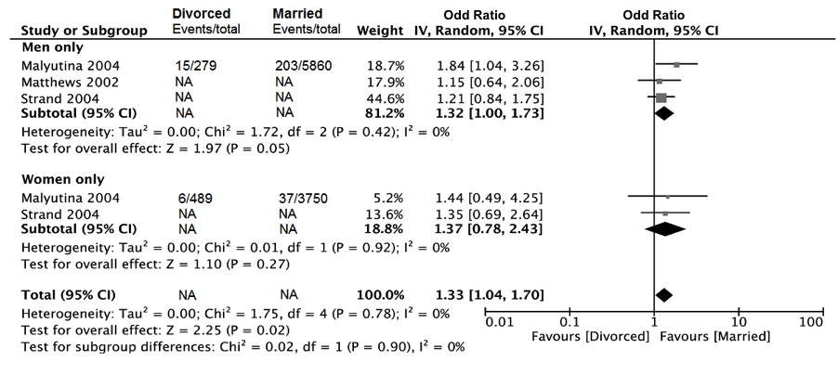

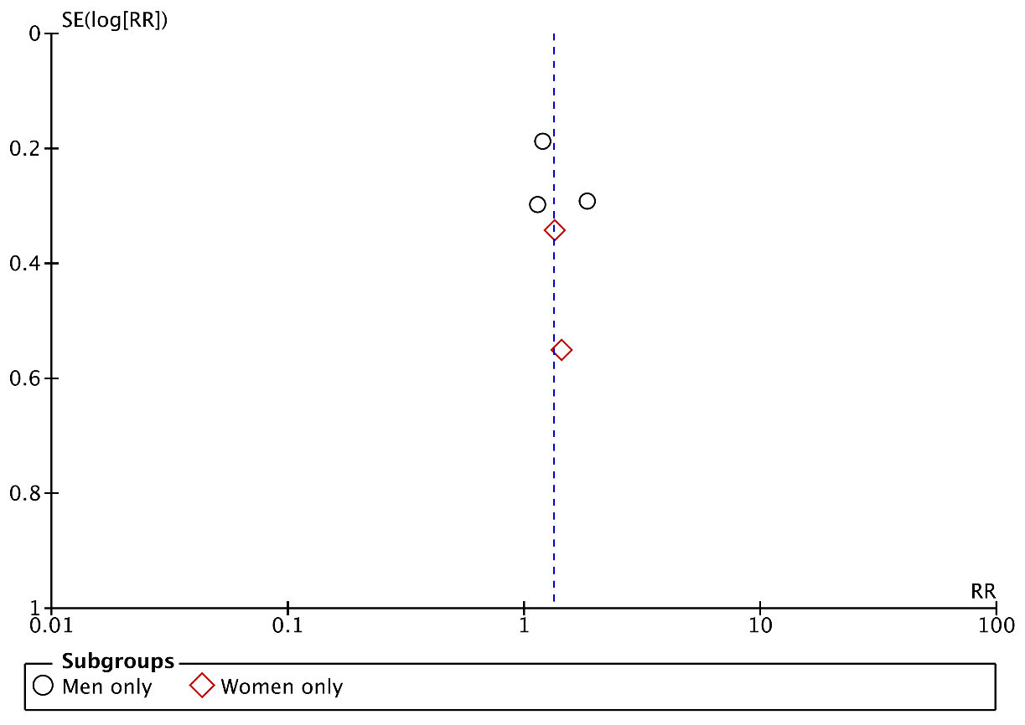
Supplementary Figure 5. Forest plot of CHD death in widowed vs married in general population and funnel plot.
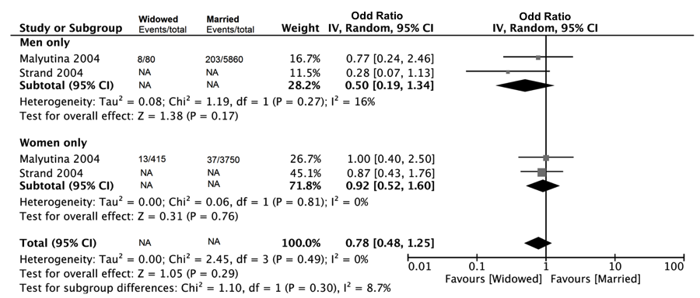

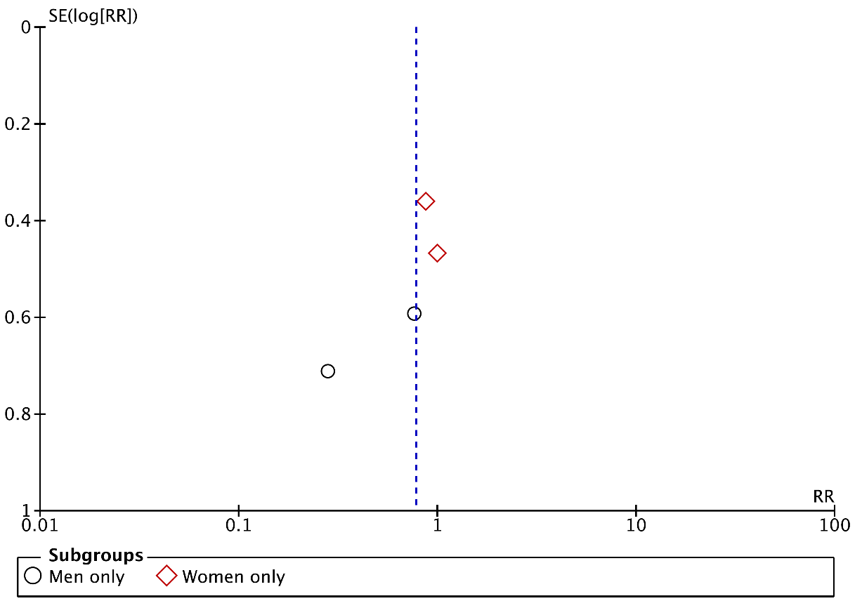
Supplementary Figure 6. Forest plot of stroke death in divorced vs married in general population and funnel plot.
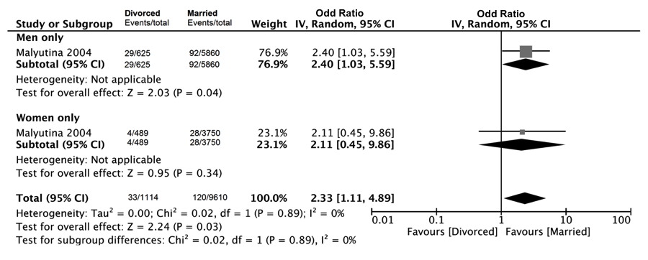

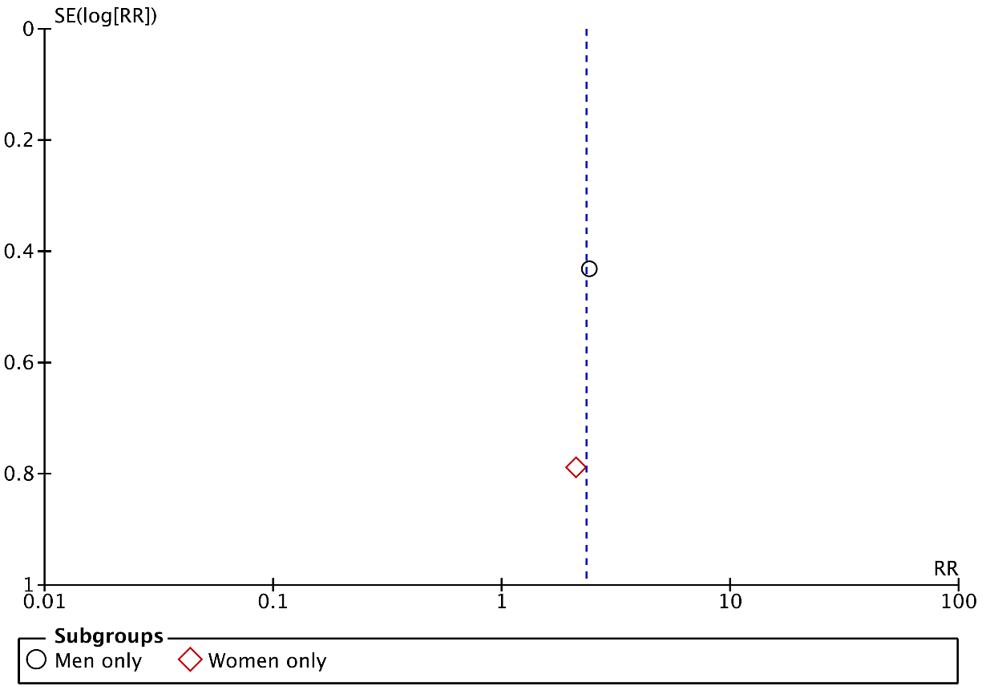
Supplementary Figure 7. Forest plot of stroke death in widowed vs married in general population and funnel plot.
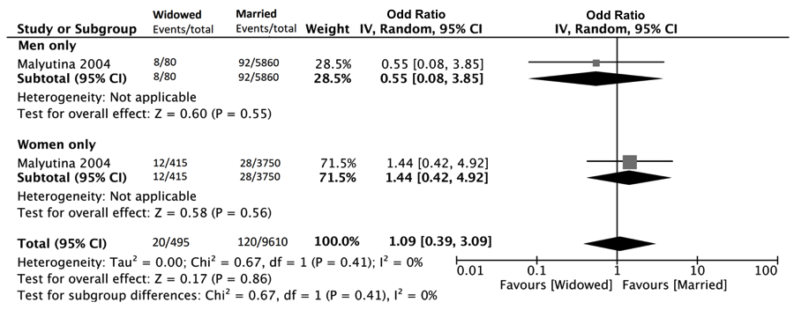

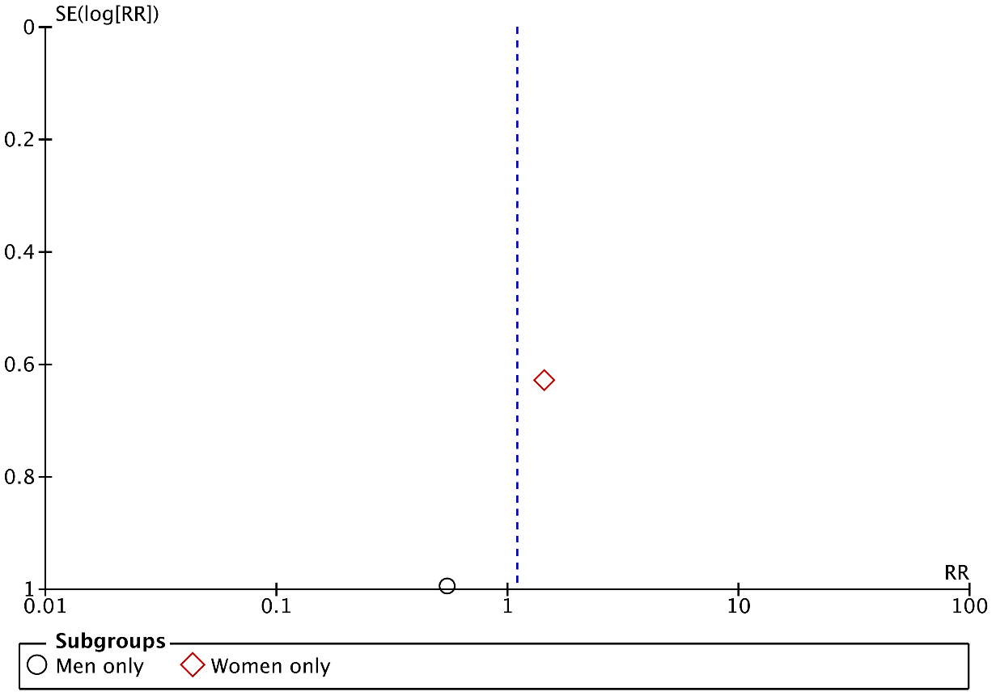
Supplementary Figure 8. Forest plot of CVD death in divorced vs married in general population and funnel plot.
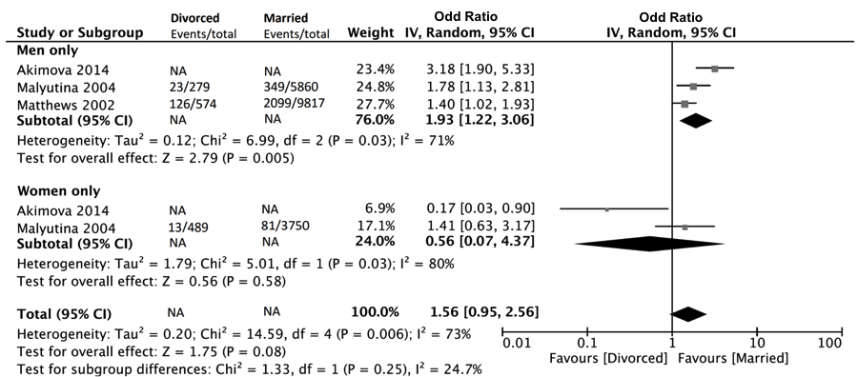

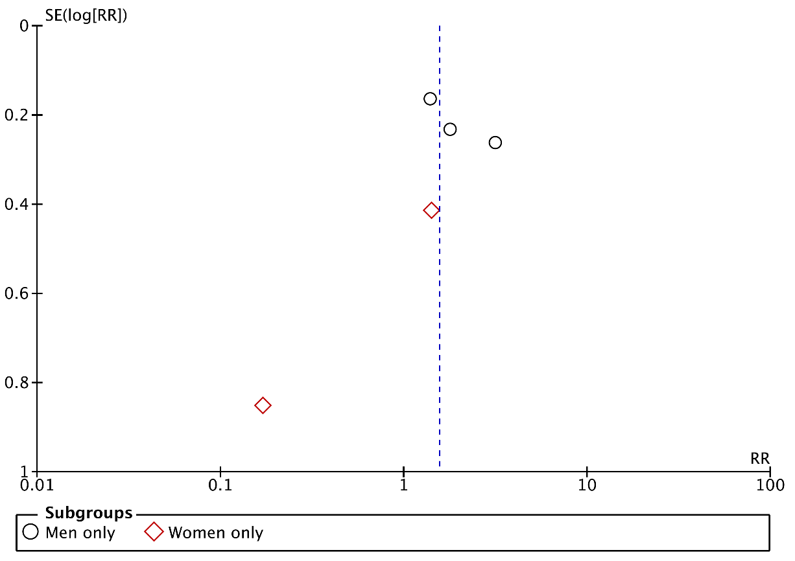
Supplementary Figure 9. Forest plot of CVD death in widowed vs married in general population and funnel plot.
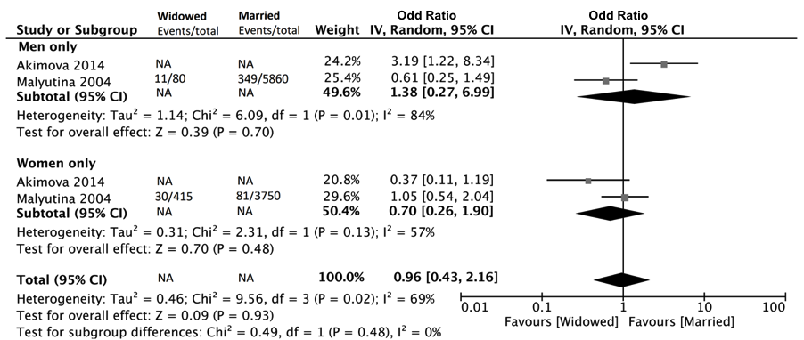

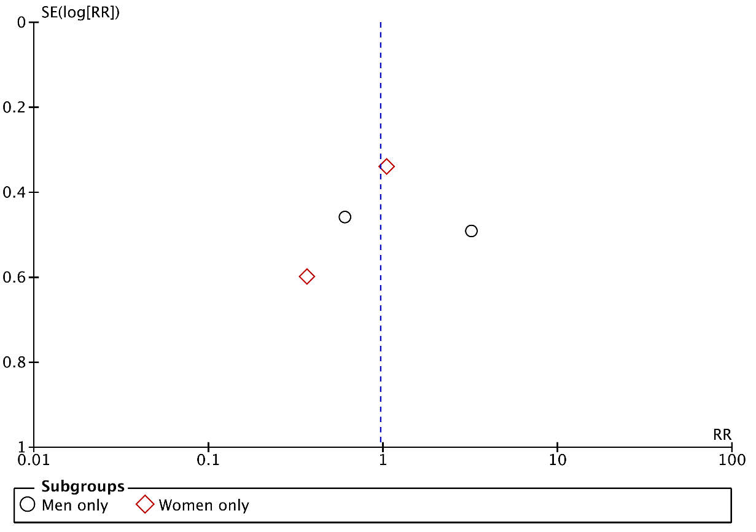
Supplementary Figure 10. Forest plot of CHD events in divorced vs married in general population and funnel plot.

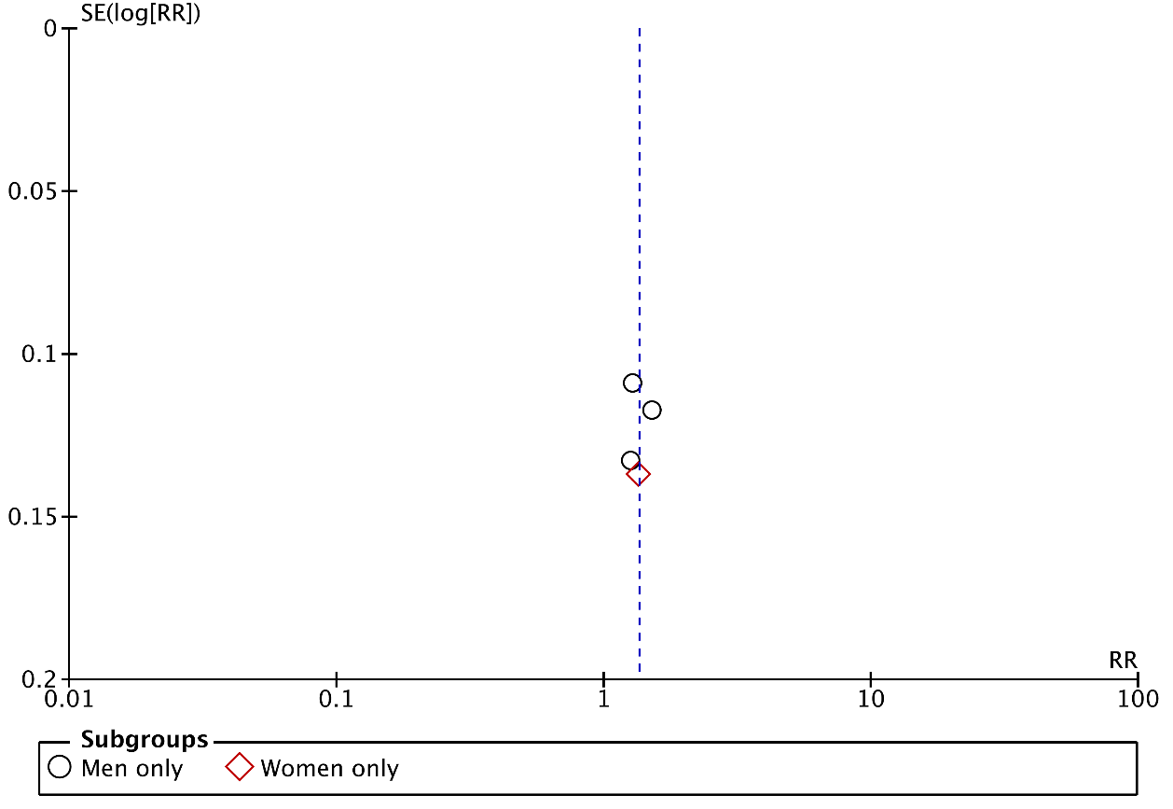
Supplementary Figure 11. Forest plot of CHD events in widowed vs married in general population and funnel plot.
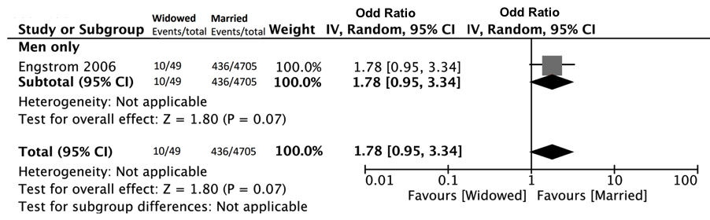

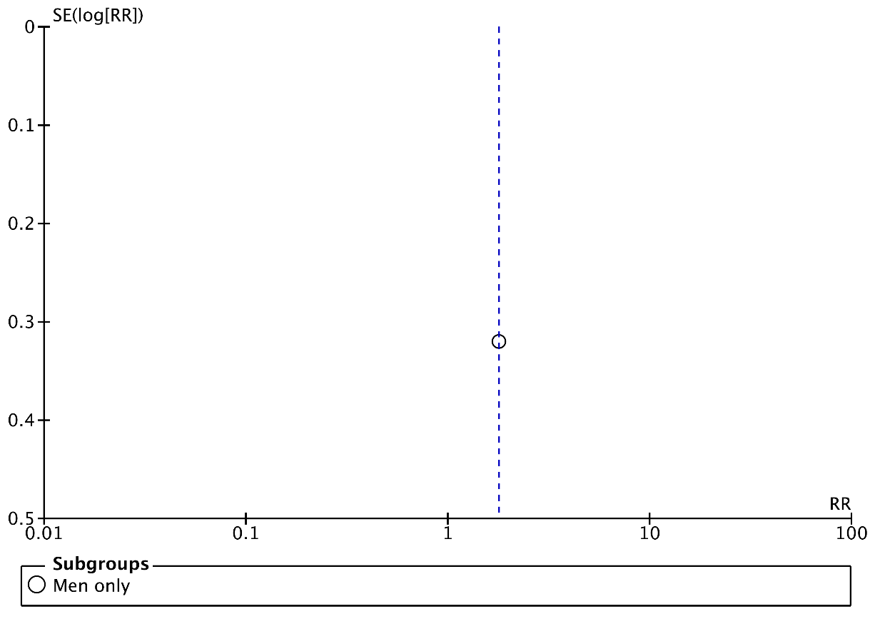
Supplementary Figure 12. Forest plot of stroke events in divorced vs married in general population and funnel plot.
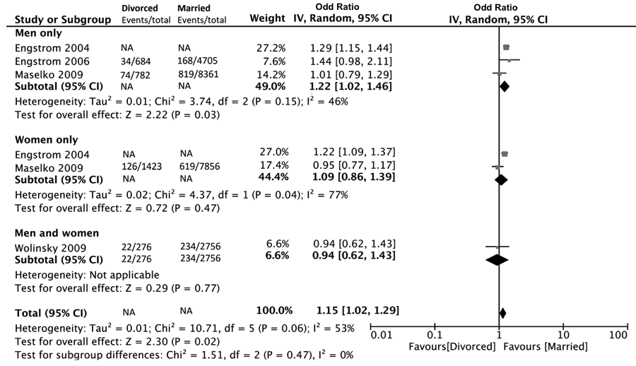

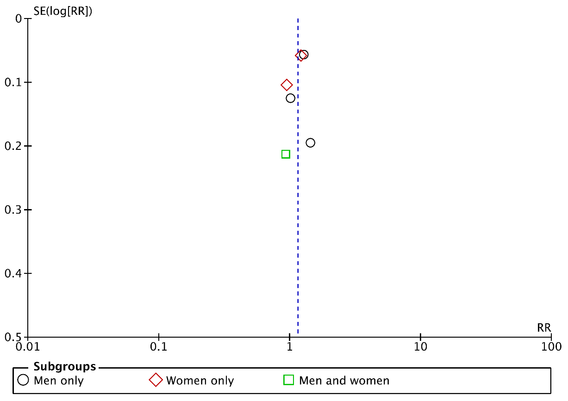
Supplementary Figure 13. Forest plot of stroke events in widowed vs married in general population and funnel plot.
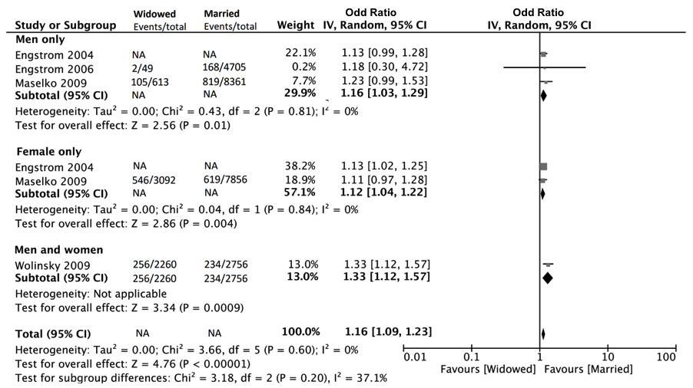

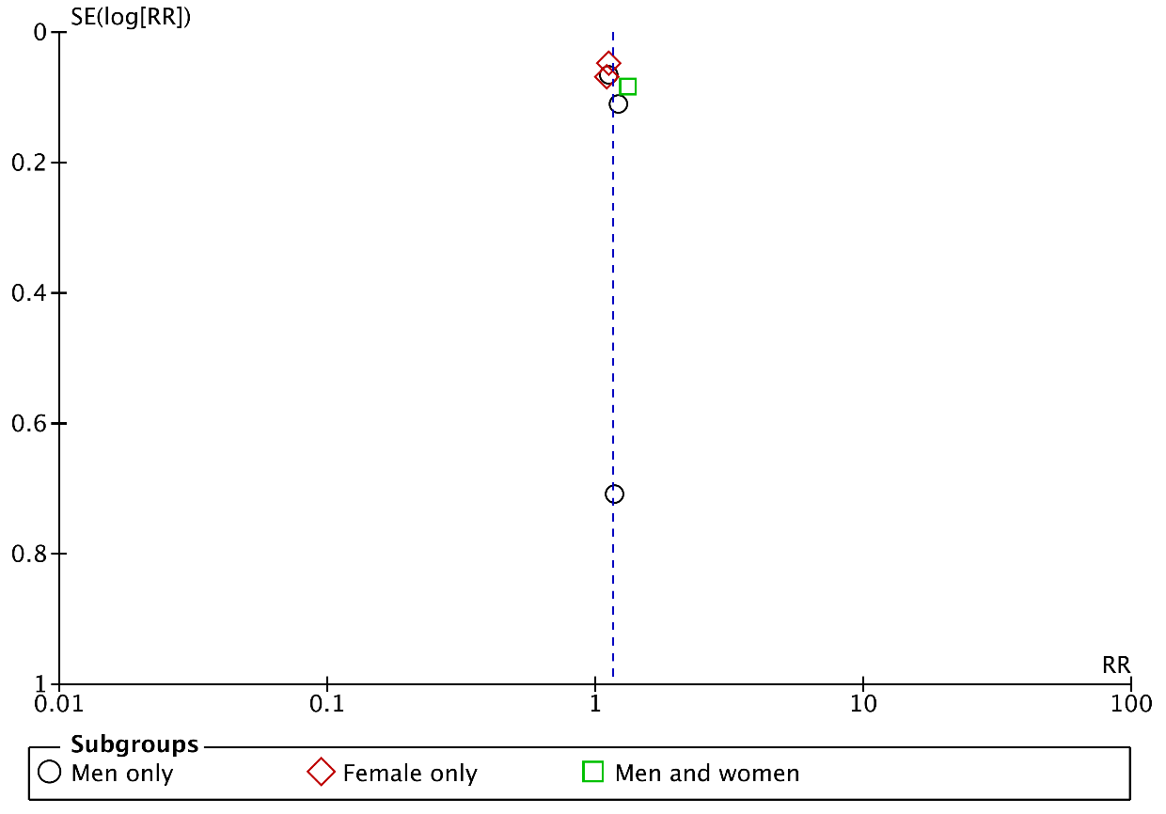
Supplementary Figure 14. Forest plot of post stroke death in unmarried vs married and funnel plot.
