Supplementary data

Supplemental Table S1
PICOS criteria for inclusion of studies
Parameter | Clinical trials | Longitudinal studies
Population | All adult populations (age > 18 years) | All adult populations (age > 18 years)
Intervention | Supplementation with vitamin K | No intervention
Comparison | Treatment versus control | Level of vitamin K dependent protein (continuous variable or high vs low)
Outcome | Vascular calcification, vascular stiffness or vitamin K dependent protein | Hazard ratio of fatal or non-fatal cardiovascular disease or mortality
Setting | Randomised or non-randomised controlled trial | Longitudinal studies

Supplemental Table S2

Meta-regression model with the mean difference (%) in a) vascular calcification and b) vascular stiffness as a dependent variable
- Impact of covariates on heterogeneity in vascular calcification studies
Variable | Unadjusted
 | Coefficient | 95% CI | P | Tau²
No covariate |  |  |  | 0.00
Year of publication | 0.25 | -6.52, 7.01 | 0.94 | 80.0
Duration of follow-up | -0.72 | -2.70,1.27 | 0.48 | 23.8
Vitamin K form (K1/K2) | 15.16 | -6.52, 36.84 | 0.17 | 0.00
Dose | -0.01 | -0.02, 0.004 | 0.23 | 0.00
Outcome | -11.74 | -32.27, 8.78 | 0.26 | 0.00
- Impact of covariates on heterogeneity in vascular stiffness studies
Variable | Unadjusted
 | Coefficient | 95% CI | P | Tau²
No covariate |  |  |  | 6.39
Year of publication | 0.55 | -0.12, 1.21 | 0.11 | 0.76
Duration of follow-up | -0.18 | -0.43, 0.07 | 0.16 | 2.83
Vitamin K form (K1/K2) | 5.98 | -2.28, 14.25 | 0.16 | 2.77
Dose | -0.01 | -0.02, 0.001 | 0.10 | 0.63
Outcome | 5.98 | -2.28, 14.25 | 0.16 | 2.77

Supplemental Table S3

Cochrane risk of bias: studies included in the vitamin K intervention analysis were assessed according to the Cochrane risk of bias tool(26). Each study was allocated a score of Low, High or Unclear for each of the factors listed in the Supplemental Table below.
Author | Year | Random sequence generation | Allocation concealment | Blinding of participants and personnel | Blinding of outcome assessment | Incomplete outcome reporting | Selective reporting | Other bias
Binkley | 2009 | Unclear | Low | Low | Low | Unclear | Low | Low
Booth | 2008 | Unclear | Low | Low | Low | Low | Low | Low
Braam | 2004 | Low | Low | Low | Low | Low | Unclear | Low
Brandenburg | 2017 | Unclear | High | Unclear | Low | Low | Unclear | Low
Dalmeijer | 2012 | Low | Unclear | Low | Low | Low | Unclear | Low
Fulton | 2016 | Low | Low | Low | Low | Low | Low | Low
Knapen | 2015 | Unclear | Low | Low | Low | Low | Low | Low
Kurnatowska | 2015 | Low | Low | Low | Low | Low | Low | Low
Kurnatowska | 2016 | Low | Low | Low | Low | Low | Unclear | Low

Supplemental Table S4
Characteristics and reported risk of cardiovascular or mortality outcomes in longitudinal studies assessing vitamin K dependent enzyme (VKDE) at baseline as continuous variable.

Author | Year | VKDE measured | Hazard ratio measurement | Outcome | HR (95% CI) | P
Schurgers | 2010 | dp-ucMGP | HR for 100pm increase in log-transformed dpucMGP | Mortality | 1.06 (1.02-1.10) | 0.005
Dalmeijer | 2013 | dp-ucMGP | HR per change in standard deviation | Fatal and non-fatal CVD | 1.37 (1-21-1.54) | Not reported
Dalmeijer | 2014 | dp-ucMGP | HR per change in standard deviation | Coronary heart disease | 1.03 (0.98-1.10) | Not reported
Liu | 2014 | dp-ucMGP | HR per increase in dp-ucMGP (squared) | Mortality | 1.02 (1.01-1.03) | <0.001
Liu | 2014 | dp-ucMGP | HR per increase in dp-ucMGP (squared) | CV events | 0.99 (0.94-1.05 | 0.87
van den Heuvel | 2014 | dp-ucMGP | HR for 100pm increase in log-transformed dpucMGP | Fatal and non-fatal CVD | 1.13 (1.02-1.24) | Not reported
Keyzer | 2015 | dp-ucMGP | HR per increase in log transformed dp-ucMGP | Mortality | 1.65 (1.26-2.16) | <0.001
Danziger | 2016 | PIVKA-II | HR per doubling of PIVKA-II | CVD (coronary heart disease, stroke, fatal CV event) | 1.46 (1.08-1.97) | 0.047

Supplemental Table S5

Ongoing studies of vitamin K supplementation on vascular health (stiffness or calcification)
Trial identifier | Source of identifier | Population | VK dose and formulation | Primary endpoint
NCT01742273 | Clinicaltrials.gov | Haemodialysis | K1 5mg 3x/wk | Progression of thoracic aorta and coronary calcification
NCT01528800 | Clinicaltrials.gov | Haemodialysis | K1 10mg 3x/wk | Progression of coronary artery calcification, cardiovascular events
NCT01002157 | Clinicaltrials.gov | Coronary artery calcification | K2 (MK7) dose unknown | Progression of coronary calcification
NCT01922804 | Clinicaltrials.gov | Postmenopausal women with osteopaenia | K2 (MK7) 375 micrograms daily | Change in bone mineral density, insulin sensitivity, arterial stiffness
NCT02404519 | Clinicaltrials.gov | Functional vitamin K deficiency | K2 (MK7) 180 micrograms daily | Change in arterial stiffness
NCT02610933 | Clinicaltrials.gov | Haemodialysis patients with atrial fibrillation | K2 (MK7) 2000 micrograms 3x/wk | Progression of thoracic aorta and coronary artery calcification, progression of arterial stiffness
ISRCTN21444964 | ISRCTN | Chronic kidney disease 3b/4 | K2 (MK7) 400 micrograms daily | Vascular stiffness

Supplemental Figure S1

Search strategy for identification of vitamin K clinical trials

(vitamin K OR menadiol OR menadione OR menaquinone OR menatetrenone OR phytonadione OR methylphytyl OR phylloquinone OR phytomenadione)
AND
(cardiovascular OR cardiac OR coronary OR vascular OR vessel OR artery OR arterial OR aorta OR stiffness OR distensibility OR calcification)

Supplemental Figure S2

Search Strategy for identification of longitudinal studies
(Matrix Gla protein OR MGP OR Osteocalcin OR PIVKA OR Vitamin K deficiency)
AND
(Cardiovascular OR Coronary OR Cardiac OR CV OR Mortality OR Death)

Supplemental Figure S3

Funnel plot including Trim and Fill analysis for assessment of publication bias for vitamin K intervention studies measuring vascular calcification. Filled circles represent log hazard ratio plotted against standard error for included studies. There are no unfilled circles (which represent studies with imputed results to balance the analysis). There is no suggestion of publication bias though with few studies for comparison.
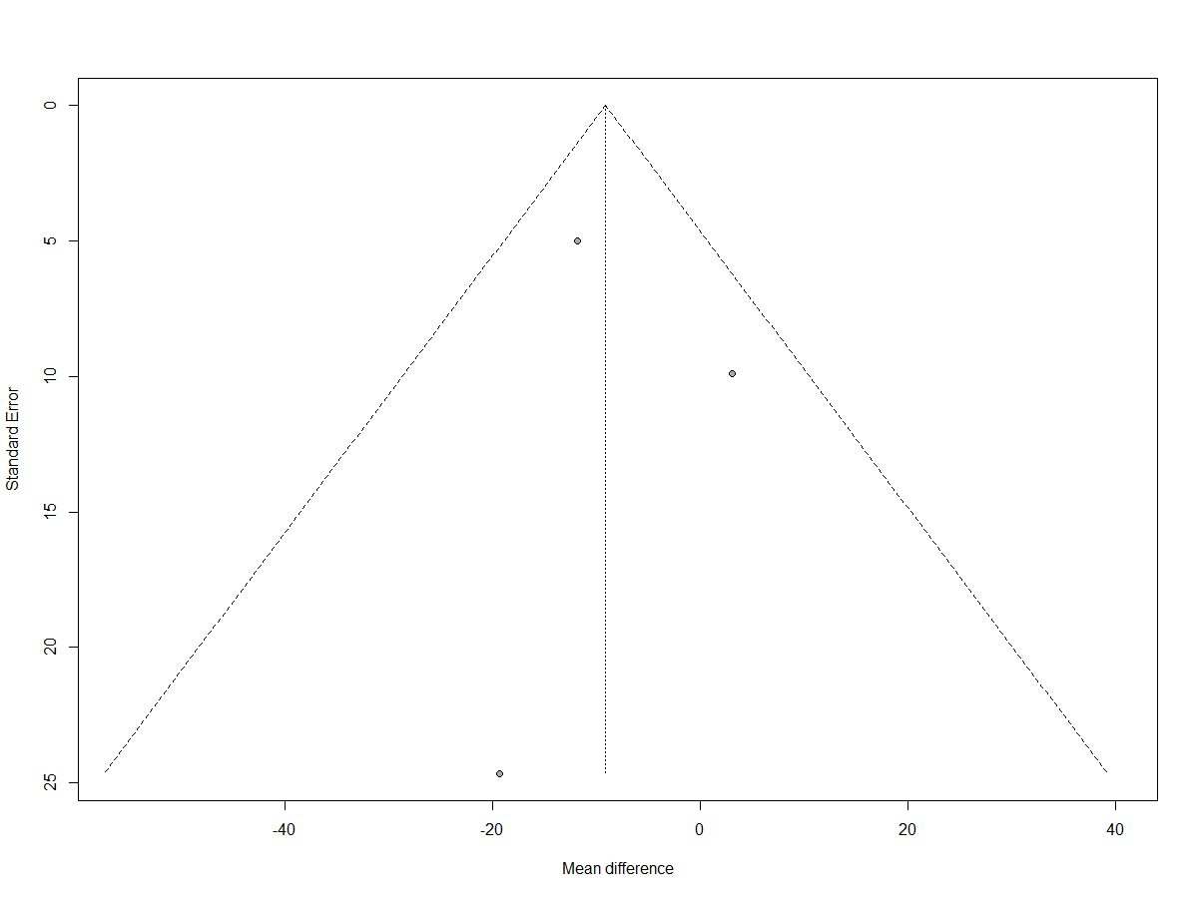

Supplemental Figure S4

Funnel plot including Trim and Fill analysis for assessment of publication bias for vitamin K intervention studies measuring effect on dp-ucMGP. Filled circles represent log hazard ratio plotted against standard error. Unfilled circles represent studies that would be expected to balance the results. There are unfilled circles to the right suggesting publication bias in favour of positive results.
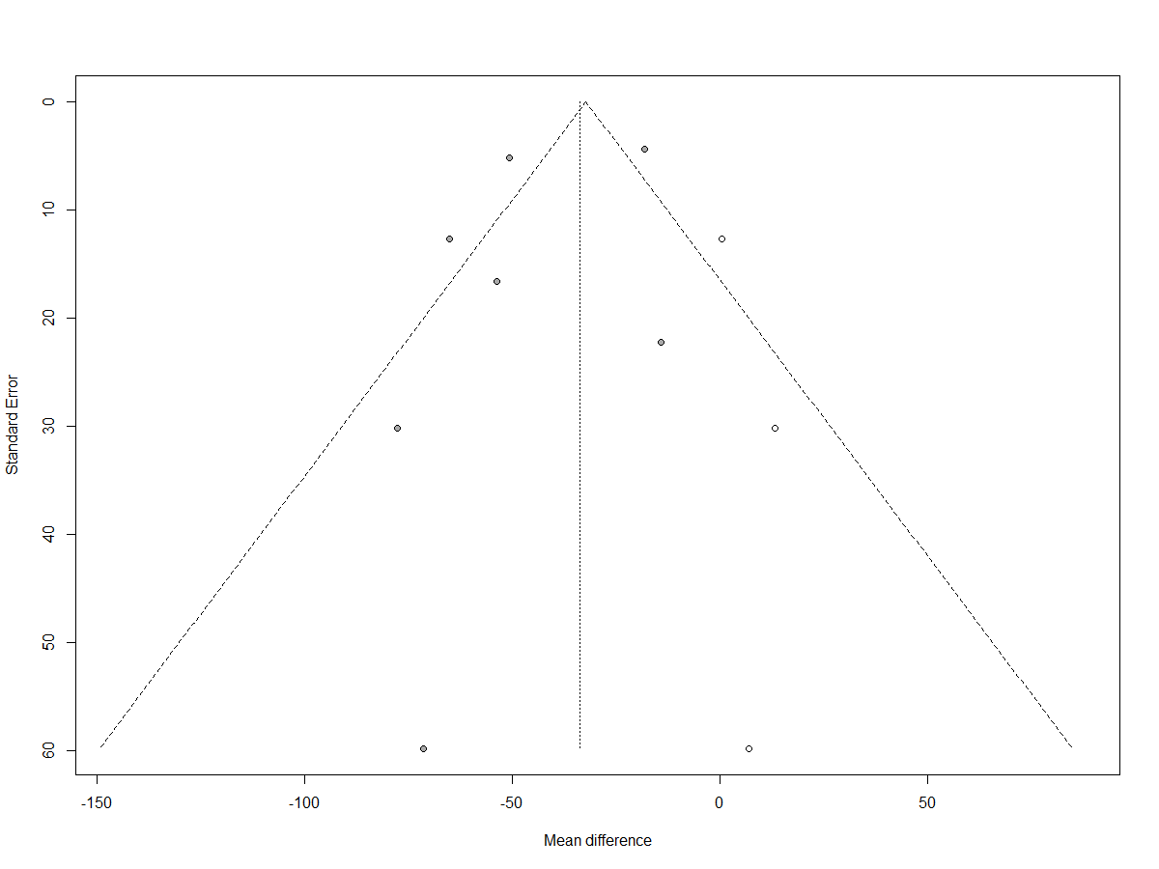

Supplemental Figure S5

Funnel plot including Trim and Fill analysis for assessment of publication bias for vitamin K intervention studies measuring effect on vascular stiffness. Filled circles represent log hazard ratio plotted against standard error. Unfilled circles represent studies that would be expected to balance the results. There is suggestion of skew to the left (which indicates favourable improvement in vascular stiffness), and therefore suggestion of publication bias in favour of positive results.
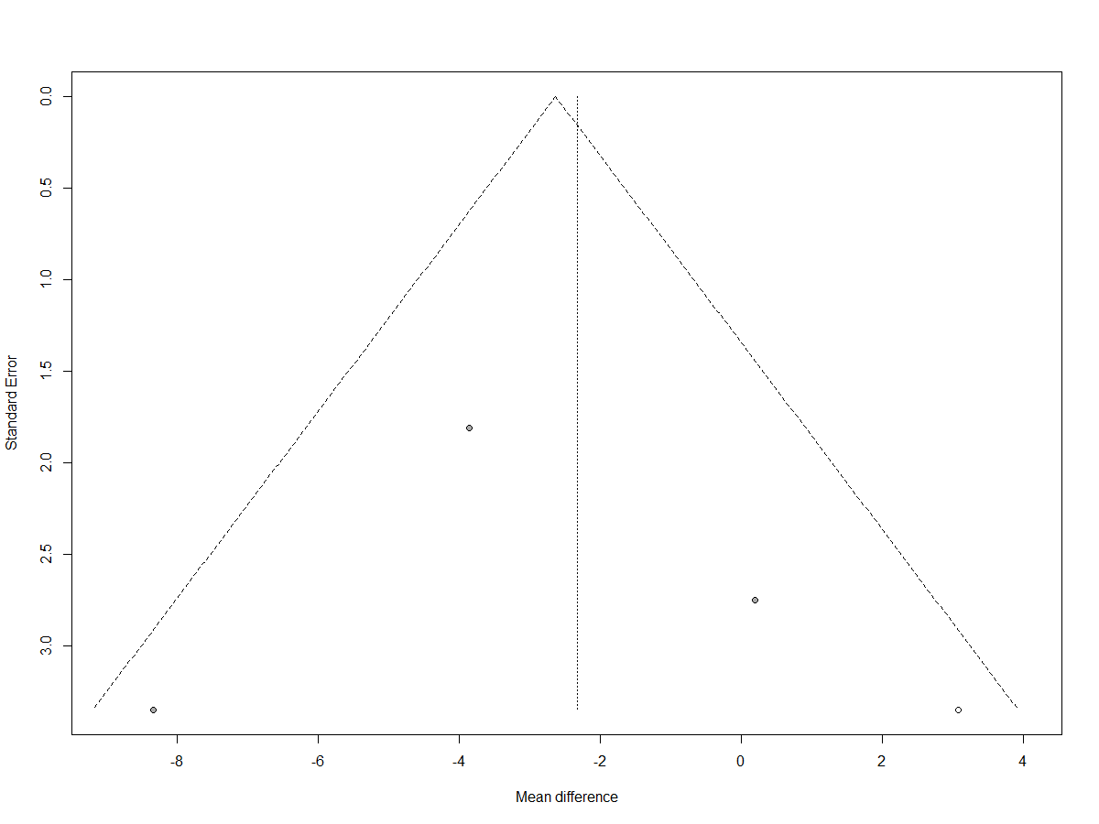

Supplemental Figure S6

Supplemental Figure S7

Funnel plot including Trim and Fill analysis for assessment of publication bias for dp-ucMGP considered “high” vs “low”. Filled circles represent log hazard ratio plotted against standard error. Unfilled circles represent studies that would be expected to balance the results. There is suggestion of skew to the right i.e. publication bias in favour of positive results.
