Supplementary Appendix

Supplementary table 1
ICD-10 codes included in Charlson co-morbidity index

Diagnostic categories, ICD-10 codes
Codes
Condition Weights ICD-10
Peripheral vascular disease 1 I70, I71, I74, I790, I739
Cerebral vascular accident 1 I60, I61, I62, I63, I65, I66, I67, I68, I69, G450, G451, G452, G458, G459, I64, G454 ,G46 I670, I671, I672, I674, I675, I676, I677, I678, I679,
I682, I688, I681
Dementia 1 F00, F01, F02, G30, G31
Pulmonary disease 1 J40, J41, J42, J43, J44, J45, J46, J47, J67, J60, J61, J62, J63, J64, J65,
J66, J67
Connective tissue disorder 1 M32, M34, M331, M053, M058, M059, M060, M063, M069, M050,
M051, M052, M353
Peptic ulcer 1 K25, K26, K27, K29, K221
Liver disease 1 K702, K703, K704, K73, K717, K740, K742, K746, K743, K744, K745
Diabetes complications 2 E102, E112, E132, E142, E103, E113, E133, E143, E104, E114, E134,
E144
Paraplegia 2 G81, G041, G820, G821, G822, T144
Renal disease 2 N03, N052, N053, N054, N055, N056, N072, N073, N074, N01, N18,
N19, N25, N17, R34, I12, I13, Z992, N04, T858, T859
Cancer 2 C0, C1, C2, C3, C40, C41, C43, C45, C46, C47, C48, C49, C5, C6, C70,
C71, C72, C73, C74, C75, C76, C80, C81, C82, C83, C84, C85, C883,
C887, C889, C900, C901, C91, C92, C93, C940, C941, C942, C942,
C9451, C947, C95, C96
Metastatic cancer 3 C77, C78, C79, C80
Severe liver disease 3 K729, K766, K767, K721, B150, B160, B190, K711
HIV 6 B20, B21, B22, B23, B24

Supplementary table 2
ICD-10 codes used in outcome and baseline variables
Heart Failure | I50
Myocardial infarction | I21, I22, 410 (ICD-8)
Pacemaker Implantation | BFCA01, BFCA03, BFCA07, BFCA61, ZZ4050A, ZZ405B
Atrial fibrillation | I48
Cardiovascular Death | I00-I99
Valvular heart disease | I05, I06, I34, I35, KFK, KFM

ICD-10 codes used in combined variables with medication
Hypertension | I10, I15
Diabetes Mellitus | E10, E11

ATC-codes used for defining medical therapy
Beta-blocker | C07A, C07B, C07C, C07D, C07F
Loop diuretics | C03C, C03EB
Calcium channel antagonist | C08, C09BB, CO9DB
RAS-inhibitor | C09AA, C09BA, C09BB, C09CA, C09DA, C09DB, C09XA02, C09XA52
Non-loop diuretics | C02L, C02DA, C07D, C09XA52, C03A, C03EA, C03B, C03X, C07C, C08G, C09BA, C09DA, C03D, C03E, C03EB
Anti-diabetic medication | A10A, A10B

Supplementary table 3 - Number of events of adverse cardiovascular outcomes per BBB subtype during follow-up.
Men
BBB subtype | CV Death  No. | HF  No. | Pacemaker implantation  No. | MI  No. | AF  No.
IRBBB (n = 887) | 37 | 53 | 14 | 38 | 67
RBBB (n = 2,297) | 244 | 276 | 156 | 137 | 258
LBBB (n = 358) | 56 | 118 | 34 | 30 | 44
NIVCD (n = 1,979) | 216 | 343 | 124 | 144 | 197
Women
BBB subtype | CV Death  No. | HF  No. | Pacemaker implantation  No. | MI  No. | AF  No.
IRBBB (n = 426) | 26 | 26 | 14 | 11 | 31
RBBB (n = 1,213) | 163 | 167 | 77 | 54 | 136
LBBB (n = 679) | 82 | 167 | 32 | 52 | 99
NIVCD (n = 1,071) | 172 | 255 | 69 | 92 | 126

Supplementary table 4 - Brier scores for all models and outcomes with 95% confidence intervals.
Men
Outcome | Conventional model  Brier score (95%CI) | BBB Model  Brier score (95%CI)
CV Death | 0.0438 (0.0378-0.0499) | 0.0439 (0.0378-0.0499)
HF | 0.0607 (0.0528-0.0686) | 0.0603 (0.0525–0.0681)
Pacemaker implant | 0.0157 (0.0132-0.0183) | 0.0155 (0.0130-0.0181)
MI | 0.0514 (0.0444-0.0583) | 0.0514 (0.0444-0.0583)
AF | 0.0735 (0.0646-0.0824) | 0.0735 (0.0646-0.0824)

Women
Outcome | Conventional model  Brier score (95%CI) | BBB Model  Brier score (95%CI)
CV Death | 0.0461 (0.0395–0.0527) | 0.0461 (0.0395–0.0527)
HF | 0.0546 (0.0469-0.0623) | 0.0544 (0.0468–0.0621)
Pacemaker implantation | 0.0116 (0.00941-0.0138) | 0.0115 (0.00938-0.0137)
MI | 0.0312 (0.0262–0.0363) | 0.0312 (0.0262–0.0362)
AF | 0.0697 (0.0608-0.0787) | 0.0697 (0.0608-0.0787)

Supplementary table 5 - Cox models used in risk prediction of the outcomes of pacemaker implantation and heart failure as well as the corresponding competing outcomes of event-free mortality.

Heart Failure:
 | Beta-coefficient | Standard  Error | P-value
No BBB | [Ref] | [Ref] | [Ref]
BBB RBBB | 0.37502 | 0.04923 | < 0.001
BBB LBBB | 1.30553 | 0.06057 | < 0.001
BBB NIVCD | 1.02830 | 0.04271 | < 0.001
BBB IRBBB | 0.09672 | 0.11449 | 0.398
Male sex | 0.43830 | 0.01968 | < 0.001
Age 40-49 | [Ref] | [Ref] | [Ref]
Age 50-59 | 0.63929 | 0.04637 | < 0.001
Age 60-69 | 1.34767 | 0.04386 | < 0.001
Age 70-79 | 2.09015 | 0.04327 | < 0.001
Age 80-89 | 2.63039 | 0.04561 | < 0.001
Age 90-99 | 3.08874 | 0.06962 | < 0.001
Comorbidity | 0.55792 | 0.01970 | < 0.001

H₀(10)= 0.051525 (10-year baseline cumulative hazard)

Competing event (Death from all causes without heart failure)
 | Beta-coefficient | Standard  Error | P-value
No BBB | [Ref] | [Ref] | [Ref]
BBB RBBB | 0.04168 | 0.03176 | 0.1894
BBB LBBB | 0.02021 | 0.06043 | 0.7381
BBB NIVCD | 0.09338 | 0.03707 | 0.0118
BBB IRBBB | 0.11049 | 0.06653 | 0.0968
Male sex | 0.38599 | 0.01188 | < 0.001
Age 40-49 | [Ref] | [Ref] | [Ref]
Age 50-59 | 0.77976 | 0.03146 | < 0.001
Age 60-69 | 1.49193 | 0.02995 | < 0.001
Age 70-79 | 2.45022 | 0.02916 | < 0.001
Age 80-89 | 3.35215 | 0.02972 | < 0.001
Age 90-99 | 4.27201 | 0.03749 | < 0.001
Comorbidity | 0.44902 | 0.01171 | < 0.001

H₀(10)= 0.13285 (10-year baseline cumulative hazard)

Pacemaker implantation
 | Beta-coefficient | Standard  Error | P-value
No BBB | [Ref] | [Ref] | [Ref]
BBB RBBB | 1.44882 | 0.07190 | < 0.001
BBB LBBB | 1.48645 | 0.12629 | < 0.001
BBB NIVCD | 1.60717 | 0.07699 | < 0.001
BBB IRBBB | 0.82529 | 0.19074 | < 0.001
Male sex | 0.49830 | 0.04394 | < 0.001
Age 40-49 | [Ref] | [Ref] | [Ref]
Age 50-59 | 1.04940 | 0.14186 | < 0.001
Age 60-69 | 2.11864 | 0.13329 | < 0.001
Age 70-79 | 2.99222 | 0.13173 | < 0.001
Age 80-89 | 3.40676 | 0.13642 | < 0.001
Age 90-99 | 3.70429 | 0.19077 | < 0.001
Comorbidity | 0.29514 | 0.04320 | < 0.001

H₀(10) = 0.0080481 (10-year baseline cumulative hazard)

Competing event (Death from all causes without pacemaker implantation)
 | Beta-coefficient | Standard  Error | P-value
No BBB | [Ref] | [Ref] | [Ref]
BBB RBBB | 0.05888 | 0.02949 | 0.0458
BBB LBBB | 0.10609 | 0.05142 | 0.0391
BBB NIVCD | 0.18861 | 0.03230 | < 0.001
BBB IRBBB | 0.11394 | 0.06278 | 0.0695
Male sex | 0.39957 | 0.01108 | < 0.001
Age 40-49 | [Ref] | [Ref] | [Ref]
Age 50-59 | 0.79474 | 0.03041 | < 0.001
Age 60-69 | 1.53413 | 0.02888 | < 0.001
Age 70-79 | 2.50249 | 0.02811 | < 0.001
Age 80-89 | 3.40871 | 0.02860 | < 0.001
Age 90-99 | 4.31612 | 0.03565 | < 0.001
Comorbidity | 0.46710 | 0.01093 | < 0.001

H₀(10)= 0.14387 (10-year baseline cumulative hazard)

Supplementary table 6 - Landmark analysis of outcome of incident HF only including individuals with event free survival at 1 year of follow-up.

 | LBBB | NIVCD
Main model | HR 3.96 (95% CI 3.30 - 4.76, P<0.001) | HR 2.37 (95% CI 2.12-2.65, P<0.001)
Landmark model | HR 3.58 (95% CI 2.84-4.52, p <0.001) | HR 1.95 (95% CI 1.69-2.25, P <0.001)
Men

 | LBBB | NIVCD
Main model | HR 2.51 (95% CI 2.15 – 3.94, P<0.001) | HR 2.80 (95% CI 2.47-3.18, P<0.001)
Landmark model | HR 2.33 (95% CI 1.92-2.82, P <0.001) | HR 2.56 (95% CI 2.19-3.00, P <0.001)
Women
Supplemental figure S1
Forest plots depicting multivariable-adjusted hazard ratios by bundle branch blocks and sex for the outcome all-cause mortality
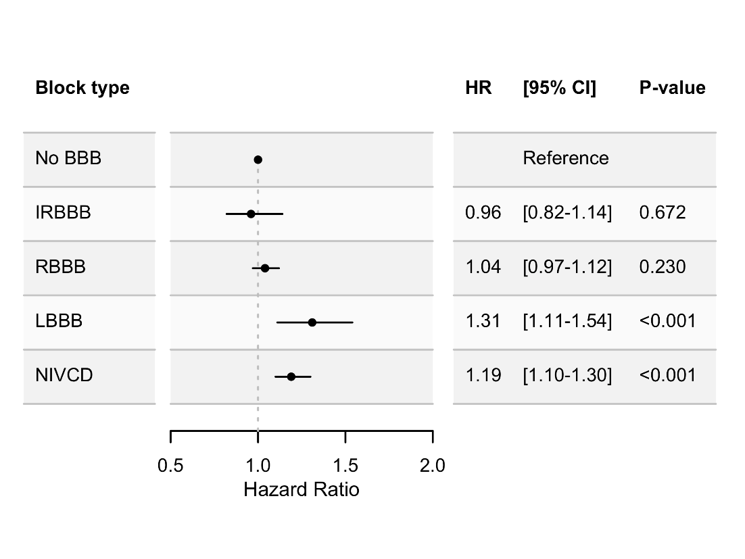
Men

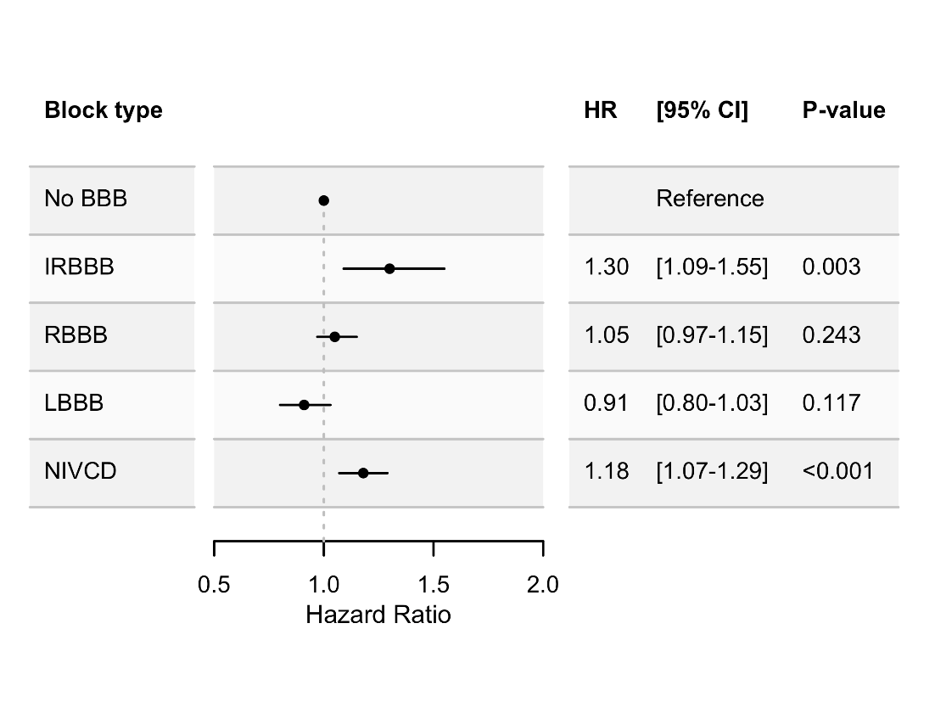
Women

Supplemental figure S2
Absolute AUC for conventional risk models for cardiovascular outcomes as well as differences in AUC with p-values for model comparison when introducing BBB subtypes to the conventional risk models.

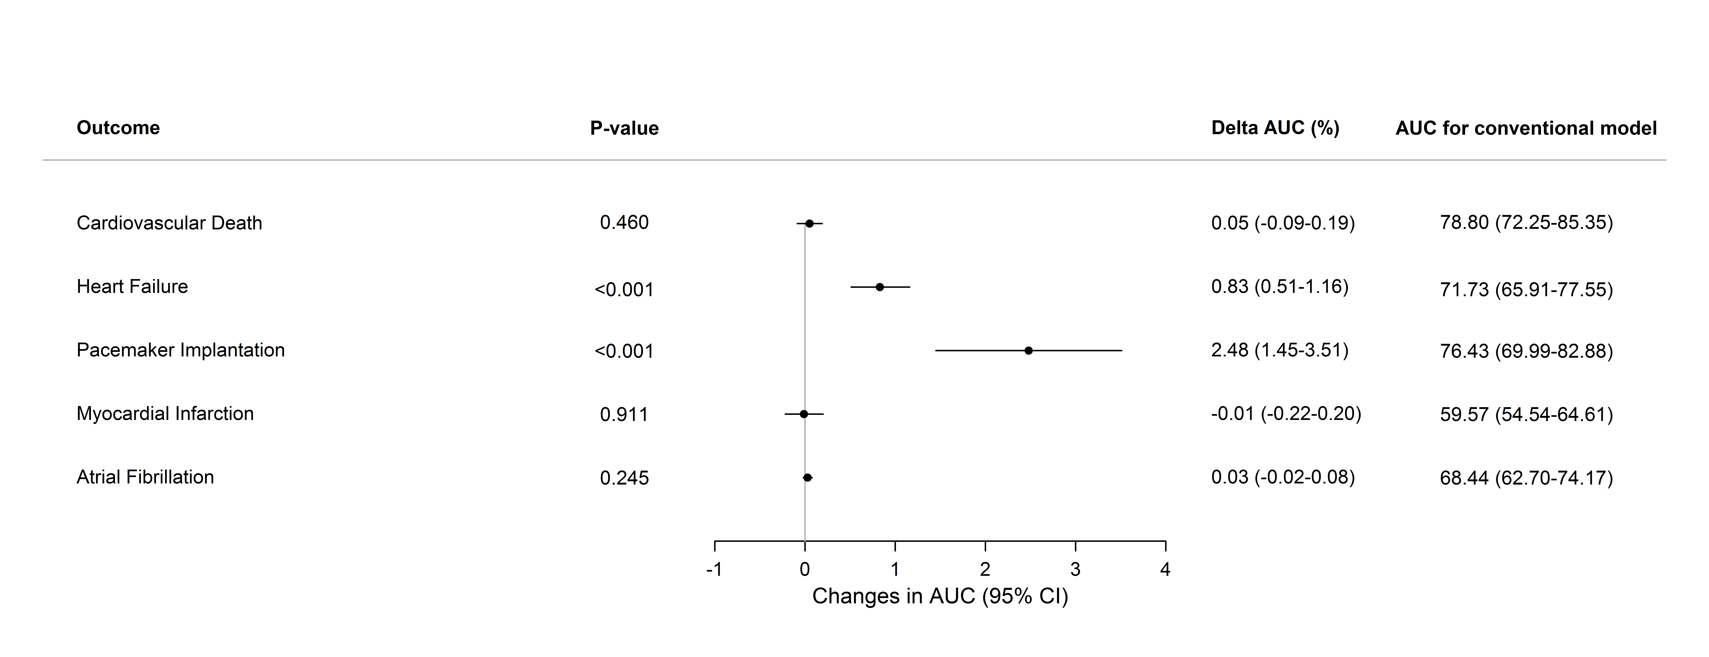
Men

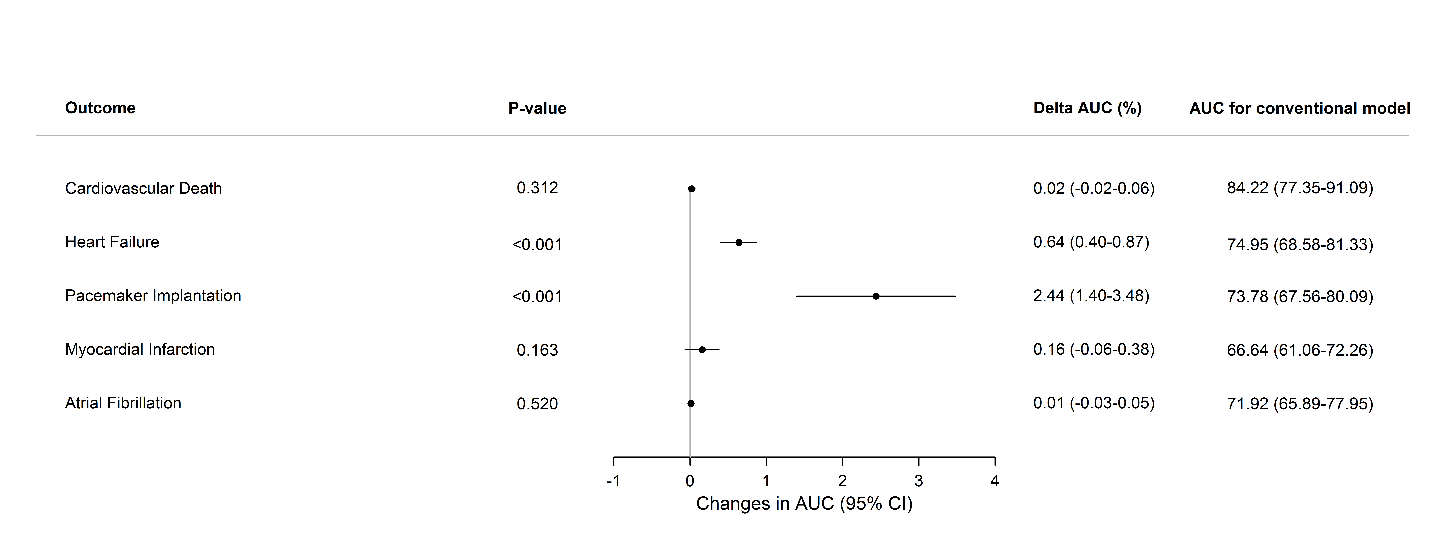
Women

Supplementary figure S3
Plots depicting model calibration for the outcomes heart failure and pacemaker implantation for both men and women. Shown are the predicted risks against the observed frequency of the outcome in question with the expected status obtained in groups defined by quantiles of the predicted risks.
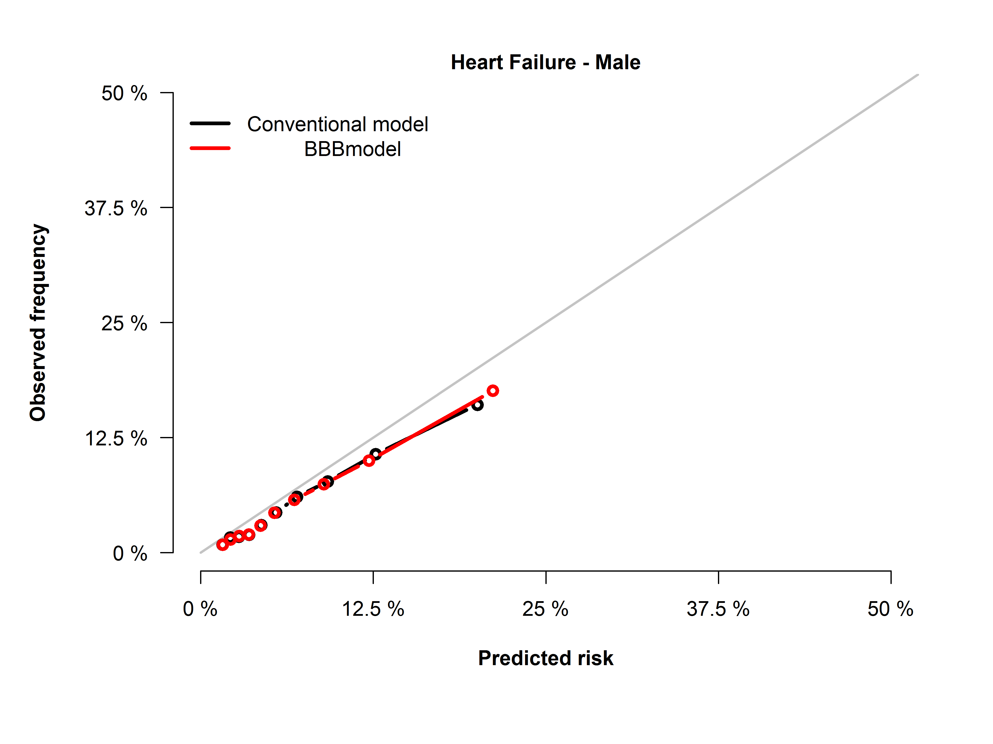
A)

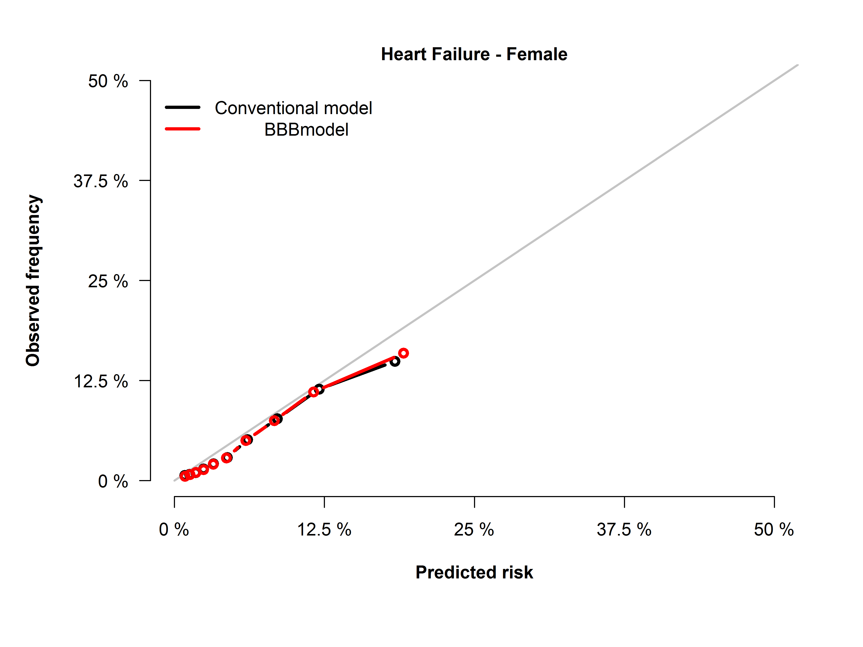
B)

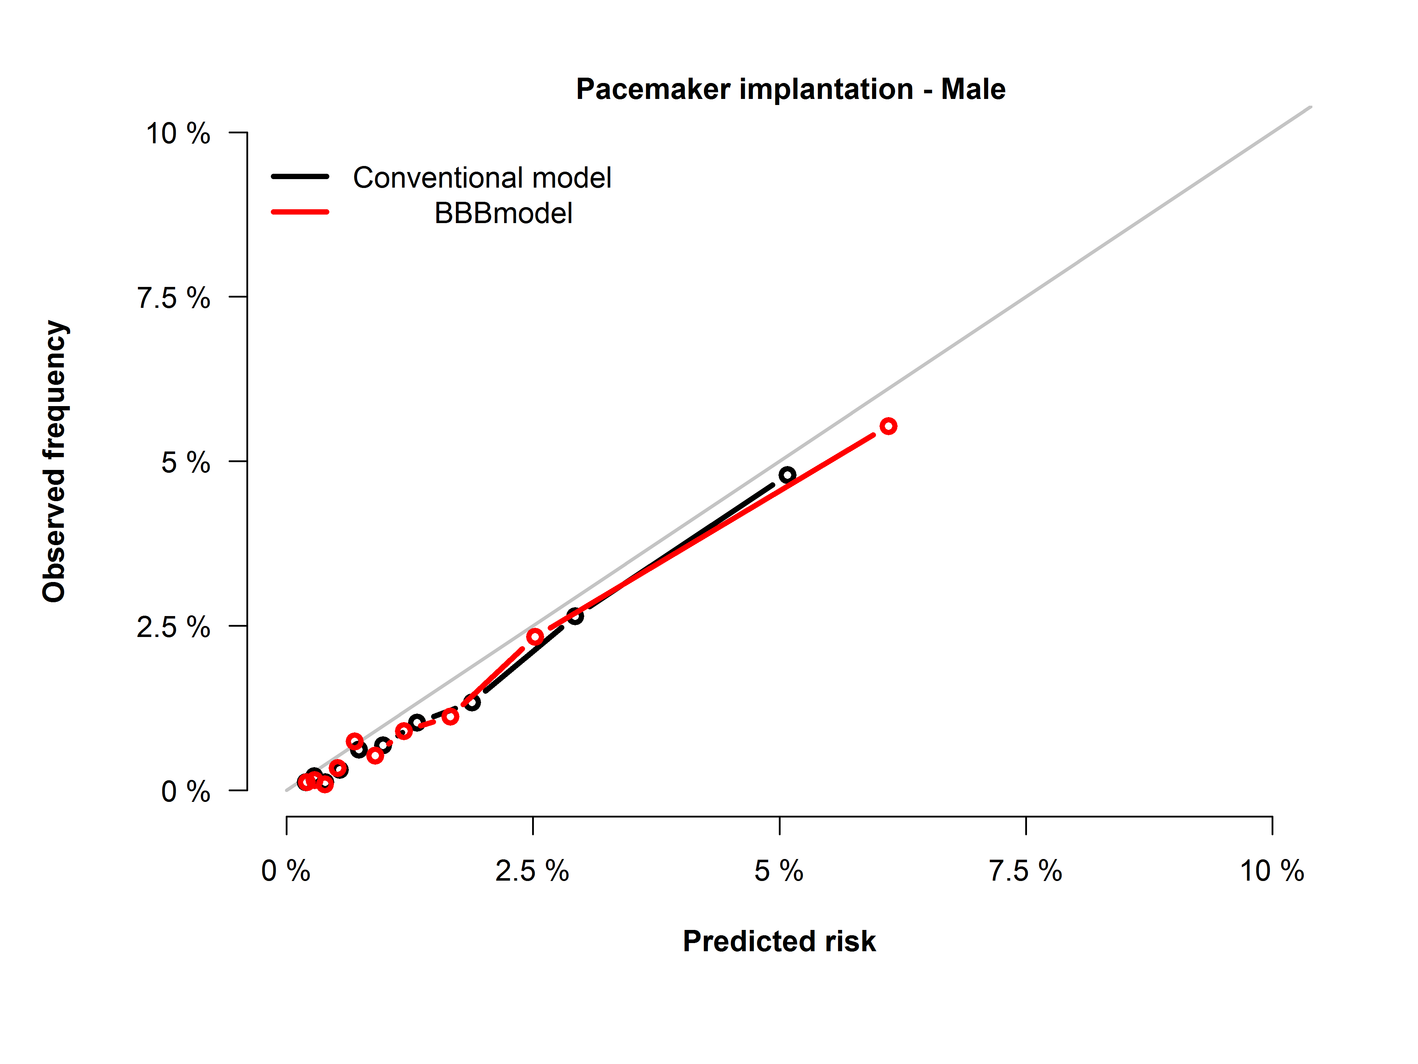
C)

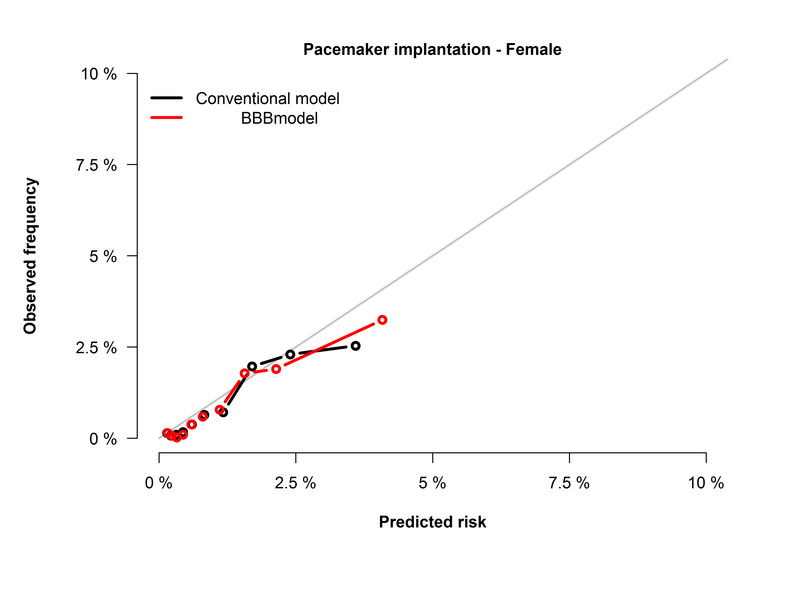
D)

