Online Supplement
Methods - Study Procedures
Echocardiography
All patients undergoing TAVI evaluation underwent comprehensive transthoracic echocardiographic examination (TTE) using commercial systems (Philips Medical Systems, Bothell, WA, Siemens Medical Solution Inc, Malvern, PA or General Electric, Milwaukee, WI). All studies and images were independently reviewed and analyzed for measurement of relevant imaging parameters by a single level III trained cardiologist with 6 years of experience (J.L.C.), who was blinded to the clinical information and outcomes. Left ventricular ejection fraction (LVEF) was assessed using the modified Simpson’s method averaged from both the apical four chamber and apical two chamber windows according to the guidelines¹. Right ventricular (RV) function was qualitatively assessed by integrating multiple views. Qualitative RV systolic function was graded as either normal or RV dysfunction (RVD) if visual qualitative evaluation considered RV systolic function as either mild, moderate or severely decreased. In addition, RV systolic function was quantitatively evaluated utilizing tricuspid annular plane systolic excursion (TAPSE). TAPSE was measured using dedicated RV view with in the apical four-chamber window, with M-mode measurement of the longitudinal systolic excursion of the tricuspid annulus. Three consecutive heart cycles were recorded and averaged for patients in sinus rhythm, whereas five cardiac cycles were averaged for those in atrial fibrillation¹. Pulmonary artery systolic pressure (PASP) was calculated using the modified Bernoulli equation which integrated the maximal tricuspid regurgitant jet velocity obtained from continuous wave Doppler from multiple views and added the estimated right atrial pressure². Right atrial pressure was estimated from the inferior vena cava size (normal ≤ 2.1 cm) and variability with respiration (> 50% diameter change with inspiration), according to the guidelines². Aortic valve was interrogated in the multiple views, noting the mean and peak aortic gradients³. Similarly, three consecutive heart cycles were recorded and averaged for patients in sinus rhythm, whereas five cardiac cycles were averaged for those in atrial fibrillation. Aortic valve area (AVA) was calculated using the continuity equation and then indexed to body surface area (BSA) according to the guidelines³. Aortic, mitral and tricuspid valve regurgitation severity were evaluated using multi-window spectral and color Doppler images and graded as none/trivial, mild, moderate, and severe by integrating assessment of jet size, vena contracta size and pulmonary/hepatic venous reversal as recommended by guidelines⁴.
TAVI Procedure
Patients underwent TAVI as part of a clinical trial or commercial use. Transfemoral route was used when possible with implanting either the self-expanding Medtronic CoreValve or Evolut-R systems (Medtronic Inc, Minneapolis, MN) or the balloon-expandable Sapien XT or S3 systems (Edwards Lifesciences, Irvine, CA). Valve type, size, and delivery route were noted. As per guidelines, post-TAVI quantification of paravalvular leak (PVL) used multiparametric comprehensive approach integrating multiple views and graded into 4 levels: none/trivial, mild, moderate and severe⁶.
STS-PROM Score Calculation
For an aortic valve replacement, one may compute an STS-PROM score (v.2.81) by entering patient values for age, sex, height, weight, LVEF, heart failure, race, ethnicity, renal failure, creatinine, cardiac presentation, cardiac symptoms, prior MI, arrhythmia, chronic lung disease, cerebrovascular disease, peripheral arterial disease, diabetes, hypertension, immunocompromised status, endocarditis, coronary anatomy, clinical status, resuscitation, cardiogenic shock, IABP, inotropes, prior cardiac intervention, mitral insufficiency, aortic insufficiency, and tricuspid insufficiency.

More information about the STS risk calculators may be found at the link below:
http://riskcalc.sts.org/stswebriskcalc/views/About%20the%20STS%20Risk%20Calculator%20v2%2081.pdf
Supplemental Table 1. TAVI Procedural Characteristics
Variables | Total | TAPSE/PASP  <0.029 cm/mmHg | TAPSE/PASP  0.029-0.043 cm/mmHg | TAPSE/PASP  0.043-0.059 cm/mmHg | TAPSE/PASP  ≥ 0.059 cm/mmHg | P-Value
Access Site |  |  |  |  |  | 0.160
Left Subclavian artery | 95 (20.8%) | 26 (22.0%) | 20 (17.7%) | 24 (21.1%) | 25 (22.3%)
Femoral artery | 337 (73.7%) | 91 (77.1%) | 87 (77.0%) | 84 (73.7%) | 75 (67.0%)
Transapical | 13 (2.8%) | 1 (0.8%) | 3 (2.7%) | 4 (3.5%) | 5 (4.5%)
Axillary | 12 (2.6%) | 0 (0.0%) | 3 (2.7%) | 2 (1.8%) | 7 (6.3%)
Valve Type |  |  |  |  |  | 0.043
Self-expanding | 369 (80.0%) | 95 (81.4%) | 89 (78.8%) | 98 (87.0%) | 87 (77.7%)
Balloon expandable | 87 (20.0%) | 22 (18.6%) | 24 (21.2%) | 16 (13.0%) | 25 (22.3%)
AV PVL at discharge |  |  |  |  |  | 0.185
None/Trace | 219 (48.0%) | 63 (53.4%) | 52 (46.0%) | 56 (49.2%) | 48 (42.9%)
Mild | 195 (42.7%) | 48 (40.7%) | 50 (44.2%) | 45 (39.5%) | 52 (46.4%)
≥ Moderate | 26 (5.7%) | 5 (5.7%) | 6 (5.3%) | 8 (7.0%) | 7 (6.3%)
New Pacemaker post-TAVI | 69 (15.1%) | 17 (14.4%) | 19 (16.8%) | 16 (14.0%) | 17 (15.2%) | 0.025
AV PVL: aortic valve paravalvular leak. TAVI: transcatheter aortic valve implantation
*p-value is comparing the two groups with Baseline PH (Improvement in PH vs. Residual PH)
**p-value is comparing all three groups (No Baseline PH vs. Improvement in PH vs. Residual PH)

Supplemental Table 2. Multivariate model Adjusted for STS-PROM

Variable | HR | 95% CI | P-Value
TAPSE/PASP (vs. ≥ 0.059 cm/mmHg)
<0.029 cm/mmHg | 2.51 | (1.26, 5.01) | 0.009
0.029-0.043 cm/mmHg | 2.54 | (1.27, 5.09) | 0.009
0.043-0.059 cm/mmHg | 2.04 | (1.00, 4.18) | 0.053
CI stands for confidence interval; HR, hazard ratio; STS-PROM, Society of Thoracic Surgeons Predicted Risk of Mortality; TAPSE/PASP, Tricuspid Annular Plane Systolic Excursion/Pulmonary Artery Systolic Pressure.

Supplemental Table 3. Multivariable model including statistically significant baseline echocardiographic variables from univariate model.

Variable | HR | 95% CI | P-Value
LVEF (per 1% increase) | 0.98 | (0.97, 0.997) | 0.015
≥ Moderate TR | 1.33 | (0.80, 2.23) | 0.271
TAPSE/PASP (vs. ≥ 0.059 cm/mmHg)
<0.029 cm/mmHg | 2.26 | (1.09, 4.69) | 0.028
0.029-0.043 cm/mmHg | 2.81 | (1.41, 5.57) | 0.003
0.043-0.059 cm/mmHg | 2.17 | (1.06, 4.45) | 0.033
CI stands for confidence interval; HR, hazard ratio; LVEF, left ventricular ejection fraction; TAPSE/PASP, Tricuspid Annular Plane Systolic Excursion/Pulmonary Artery Systolic Pressure; TR, tricuspid regurgitation.

Supplemental Table 4. Sensitivity Analysis removing patients with baseline ≥ Moderate MR and/or ≥ Moderate TR (total n=347)

Variable | Unadjusted |  |  | Adjusted for STS-PROM
 | HR | 95% CI | P-Value | HR | 95% CI | P-Value
TAPSE/PASP (vs. ≥ 0.059 cm/mmHg)
<0.029 cm/mmHg | 2.79 | (1.33, 5.88) | 0.007 | 2.34 | (1.09, 5.00) | 0.028
0.029-0.043 cm/mmHg | 2.43 | (1.18, 5.03) | 0.016 | 1.90 | (0.89, 4.04) | 0.095
0.043-0.059 cm/mmHg | 1.92 | (0.93, 3.96) | 0.078 | 1.77 | (0.85, 3.67) | 0.127
CI stands for confidence interval; HR, hazard ratio; MR, Mitral Regurgitation; TR, Tricuspid Regurgitation; TAPSE/PASP, Tricuspid Annular Plane Systolic Excursion/Pulmonary Artery Systolic Pressure; STS-PROM, Society of Thoracic Surgeons Predicted Risk of Mortality.

Supplemental Table 5A. Sensitivity Analysis including only male patients (N=235)
Variable | Unadjusted |  |  | Adjusted for age, AF, LVEF, SVI, and STS-PROM
 | HR | 95% CI | P-Value | HR | 95% CI | P-Value
TAPSE/PASP (vs. ≥ 0.059 cm/mmHg)
<0.029 cm/mmHg | 3.73 | (1.41, 9.90) | 0.008 | 2.99 | (1.07, 8.32) | 0.036
0.029-0.043 cm/mmHg | 4.77 | (1.78, 12.8) | 0.002 | 3.31 | (1.16, 9.46) | 0.023
0.043-0.059 cm/mmHg | 2.38 | (0.83, 6.86) | 0.107 | 2.35 | (0.81, 6.81) | 0.115

Supplemental Table 5B. Sensitivity Analysis including only female patients (N=222)
Variable | Unadjusted |  |  | Adjusted for age, AF, LVEF, SVI, and STS-PROM
 | HR | 95% CI | P-Value | HR | 95% CI | P-Value
TAPSE/PASP (vs. ≥ 0.059 cm/mmHg)
<0.029 cm/mmHg | 2.13 | (0.80, 5.63) | 0.132 | 1.79 | (0.64, 5.01) | 0.215
0.029-0.043 cm/mmHg | 2.03 | (0.79, 5.23) | 0.141 | 1.85 | (0.69, 4.90) | 0.283
0.043-0.059 cm/mmHg | 1.90 | (0.72, 5.01) | 0.197 | 1.74 | (0.63, 4.85) | 0.265

Supplemental Table 6. Sensitivity Analysis including only patients without prior CABG (N=316)
Variable | Unadjusted |  |  | Adjusted for age, AF, LVEF, SVI, and STS-PROM
 | HR | 95% CI | P-Value | HR | 95% CI | P-Value
TAPSE/PASP (vs. ≥ 0.059 cm/mmHg)
<0.029 cm/mmHg | 2.59 | (1.24, 5.38) | 0.199 | 2.08 | (0.95, 4.59) | 0.068
0.029-0.043 cm/mmHg | 2.96 | (1.45, 6.03) | 0.003 | 2.71 | (1.31, 5.63) | 0.007
0.043-0.059 cm/mmHg | 2.59 | (1.24, 5.38) | 0.199 | 2.08 | (0.95, 4.59) | 0.068

Supplemental Table 7. Univariate Cox Proportional Hazards associations between all Clinical and Echocardiographic Characteristics and All-Cause Mortality
 | Hazard Ratio | 95% CI | P value
Clinical Characteristics
Age (per year) | 0.99 | (0.97, 1.02) | 0.67
Male Gender | 1.16 | (0.79, 1.71) | 0.45
BMI (per kg/m²) | 0.98 | (0.94, 1.01) | 0.17
Current Smoker | 0.91 | (0.42, 1.96) | 0.81
Diabetes | 1.13 | (0.77, 1.68) | 0.53
Dyslipidemia | 0.98 | (0.63, 1.54) | 0.94
Hypertension | 0.96 | (0.52, 1.80) | 0.91
Previous CABG | 0.82 | (0.53, 1.25) | 0.35
Previous Valve Surgery | 1.38 | (0.70, 2.73) | 0.36
Previous MI | 1.33 | (0.90, 1.98) | 0.15
Prior CHF | 1.34 | (0.85, 2.11) | 0.21
STS-PROM (per 1%) | 1.07 | (1.03, 1.10) | <0.01
Chronic Lung Disease | 1.38 | (0.94, 2.03) | 0.10
Atrial Fibrillation/Flutter | 1.70 | (1.15, 2.51) | <0.01
Echocardiographic Characteristics
LVEDD (cm) | 1.09 | (0.86, 1.38) | 0.46
LVESD (cm) | 1.14 | (0.94, 1.37) | 0.19
LAVI (ml/m²) | 1.008 | (0.997, 1.019) | 0.14
LVMI (g/m²) | 1.002 | (0.997, 1.006) | 0.42
LVEF (%) | 0.980 | (0.967, 0.993) | <0.01
SVI (ml/m²) | 0.987 | (0.968, 1.007) | 0.21
AV Mean Gradient (mmHg) | 0.986 | (0.974, 0.999) | 0.04
AVA (cm²) | 1.11 | (0.42, 2.92) | 0.83
AVAi (cm²/m²) | 1.63 | (0.24, 10.91) | 0.61
Lateral E/e’ | 0.977 | (0.953, 1.001) | 0.06
Septal E/e’ | 0.994 | (0.973, 1.014) | 0.54
Qualitative RV Systolic Function
Normal | 1.00 | (ref) | (ref)
Mild Decrease | 1.97 | (1.02, 3.81) | 0.04
Moderate Decrease | 1.50 | (0.66, 3.44) | 0.34
Severe Decrease | 5.94 | (0.82, 42.8) | 0.08
TAPSE (cm) | 0.72 | (0.50, 1.04) | 0.07
PASP (mmHg) | 1.013 | (1.003, 1.024) | 0.01
Moderate-Severe MR | 1.19 | (0.67, 2.13) | 0.55
Moderate-Severe TR | 1.82 | (1.15, 2.87) | 0.01
AVA stands for aortic valve area; AVAi, aortic valve area index; BMI, body mass index; CABG, coronary artery bypass graft; CHF, congestive heart failure; CI, confidence interval; E/e’, ratio of early diastolic filling/tissue Doppler velocity annulus; LVEDD, left ventricular end-diastolic diameter; LVESD, left ventricular end-systolic diameter; LAVI, left atrial volume index; LVEF, left ventricular ejection fraction, LVMI, left ventricular mass index; MI, myocardial infarction; MR, mitral regurgitation; STS-PROM, Society of Thoracic Surgeons Predicted Risk of Mortality; SVI, stroke volume index; TAPSE, tricuspid annular plane systolic excursion; TAPSE/PASP, Tricuspid Annular Plane Systolic Excursion/Pulmonary Artery Systolic Pressure; TR, tricuspid regurgitation; PASP, pulmonary artery systolic pressure.
Supplemental Figures
Figure S1 – Unadjusted Survival Analysis for male patients who received TAVI according to baseline TAPSE/PASP quartiles
Figure S2 – Unadjusted Survival Analysis for female patients who received TAVI according to baseline TAPSE/PASP quartiles
Figure S3 – Unadjusted Survival Analysis including only patients without prior CABG (n=316)

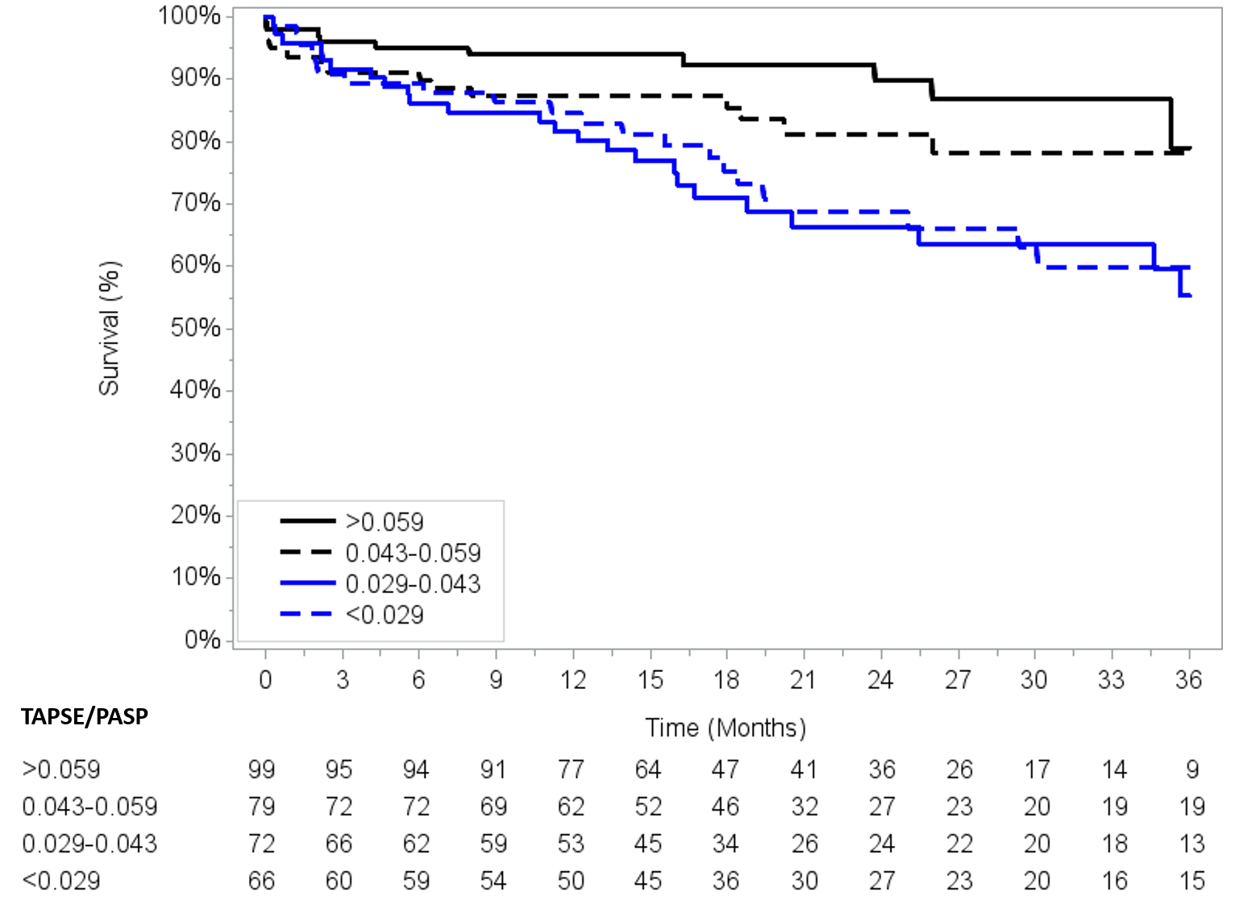
Online Supplement References:
1. Lang RM, Badano LP, Mor-Avi V, Afilalo J, Armstrong A, Ernande L, Flachskampf FA, Foster E, Goldstein SA, Kuznetsova T, Lancellotti P, Muraru D, Picard MH, Rietzschel ER, Rudski L, Spencer KT, Tsang W and Voigt JU. Recommendations for cardiac chamber quantification by echocardiography in adults: an update from the American Society of Echocardiography and the European Association of Cardiovascular Imaging. J Am Soc Echocardiogr 2015;28:1-39.e14.
2. Rudski LG, Lai WW, Afilalo J, Hua L, Handschumacher MD, Chandrasekaran K, Solomon SD, Louie EK and Schiller NB. Guidelines for the echocardiographic assessment of the right heart in adults: a report from the American Society of Echocardiography endorsed by the European Association of Echocardiography, a registered branch of the European Society of Cardiology, and the Canadian Society of Echocardiography. J Am Soc Echocardiogr 2010;23:685-713; quiz 786-8.
3. Baumgartner H, Hung J, Bermejo J, Chambers JB, Evangelista A, Griffin BP, Iung B, Otto CM, Pellikka PA and Quinones M. Echocardiographic assessment of valve stenosis: EAE/ASE recommendations for clinical practice. J Am Soc Echocardiogr 2009;22:1-23; quiz 101-2.
4. Zoghbi WA, Enriquez-Sarano M, Foster E, Grayburn PA, Kraft CD, Levine RA, Nihoyannopoulos P, Otto CM, Quinones MA, Rakowski H, Stewart WJ, Waggoner A and Weissman NJ. Recommendations for evaluation of the severity of native valvular regurgitation with two-dimensional and Doppler echocardiography. J Am Soc Echocardiogr 2003;16:777-802.
5. Galie N, Humbert M, Vachiery JL, Gibbs S, Lang I, Torbicki A, Simonneau G, Peacock A, Vonk Noordegraaf A, Beghetti M, Ghofrani A, Gomez Sanchez MA, Hansmann G, Klepetko W, Lancellotti P, Matucci M, McDonagh T, Pierard LA, Trindade PT, Zompatori M, Hoeper M, Aboyans V, Vaz Carneiro A, Achenbach S, Agewall S, Allanore Y, Asteggiano R, Paolo Badano L, Albert Barbera J, Bouvaist H, Bueno H, Byrne RA, Carerj S, Castro G, Erol C, Falk V, Funck-Brentano C, Gorenflo M, Granton J, Iung B, Kiely DG, Kirchhof P, Kjellstrom B, Landmesser U, Lekakis J, Lionis C, Lip GY, Orfanos SE, Park MH, Piepoli MF, Ponikowski P, Revel MP, Rigau D, Rosenkranz S, Voller H and Luis Zamorano J. 2015 ESC/ERS Guidelines for the diagnosis and treatment of pulmonary hypertension: The Joint Task Force for the Diagnosis and Treatment of Pulmonary Hypertension of the European Society of Cardiology (ESC) and the European Respiratory Society (ERS): Endorsed by: Association for European Paediatric and Congenital Cardiology (AEPC), International Society for Heart and Lung Transplantation (ISHLT). Eur Heart J 2016;37:67-119.
6. Kappetein AP, Head SJ, Genereux P, Piazza N, van Mieghem NM, Blackstone EH, Brott TG, Cohen DJ, Cutlip DE, van Es GA, Hahn RT, Kirtane AJ, Krucoff MW, Kodali S, Mack MJ, Mehran R, Rodes-Cabau J, Vranckx P, Webb JG, Windecker S, Serruys PW and Leon MB. Updated standardized endpoint definitions for transcatheter aortic valve implantation: the Valve Academic Research Consortium-2 consensus document. J Am Coll Cardiol 2012;60:1438-54.

