Multiple Choice Questions
Question 1:
Which of the following arrhythmias is usually not seen in a structurally normal heart?
- Right ventricular outflow tract ventricular tachycardia.
- Fascicular reentry ventricular tachycardia.
- Bundle branch reentry ventricular tachycardia.
- Catecholaminergic polymorphic ventricular tachycardia.
- Tricuspid annular ventricular tachycardia.

Answer C:
Bundle branch reentry ventricular tachycardia results from a macro-reentrant circuit involving the right and left bundle branches. It usually manifests as monomorphic tachycardia, typically with left bundle branch block morphology and is usually seen in patients who have structurally abnormal hearts such as dilated cardiomyopathy and valvular heart disease. It may be associated with syncope and sudden death. Right ventricular outflow tract ventricular tachycardia (answer A), fascicular reentry ventricular tachycardia (answer B), catecholaminergic polymorphic ventricular tachycardia (CPVT, answer D) and peri-tricuspid annular ventricular tachycardia (answer E) are usually seen in patients without demonstrable structural heart disease. CPVT manifests as adrenergic-induced bidirectional and/or polymorphic ventricular tachycardia. Peri-tricuspid annular ventricular tachycardia is infrequent and accounts for <10% of idiopathic ventricular tachycardias.

Question 2:
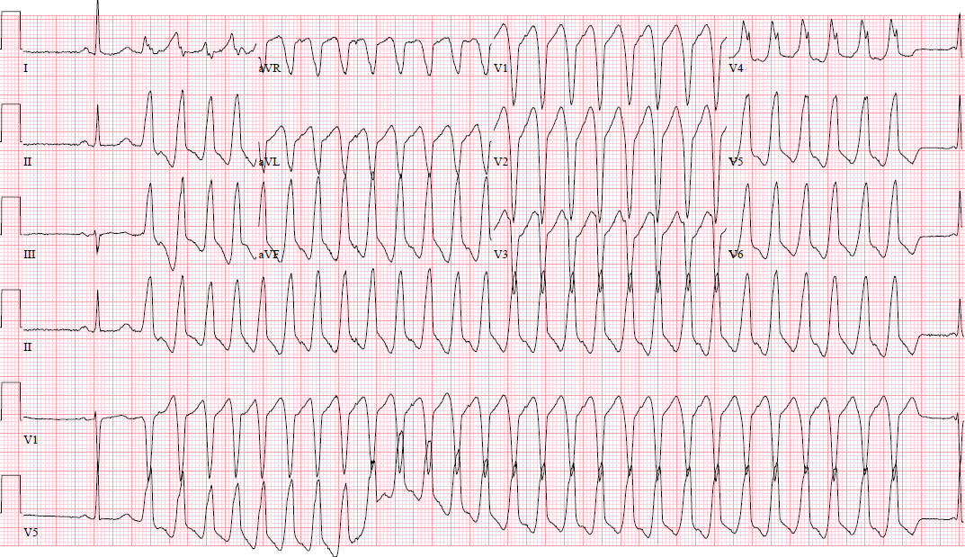
What is the most appropriate management option for a 45 year old female with palpitations and this ECG?
- Transvenous implantable cardioverter defibrillator implantation alone.
- Subcutaneous implantable cardioverter defibrillator implantation alone.
- Catheter ablation.
- Catheter ablation and transvenous implantable cardioverter defibrillator implantation.
- Observation alone.

Answer = C.
This ECG demonstrates monomorphic ventricular tachycardia (MMVT) arising from the right ventricular outflow tract (RVOT). Ventricular tachycardia is suggested by the wide QRS complexes and VA dissociation. The RVOT origin is suggested by the left bundle branch block morphology in lead V1, inferior axis (positive QRS in II, III, aVF and negative in aVL and aVR). This is the most common arrhythmia in patients with structurally normal hearts. Catheter ablation yields a >80% long-term success rate and current guidelines provide a Class I, level of evidence B, recommendation for catheter ablation in symptomatic outflow tract ventricular arrhythmias in an otherwise normal heart for whom antiarrhythmic medications are ineffective, not tolerated, or not the patient’s preference. An implantable cardioverter defibrillators (ICD, transvenous or subcutaneous, answers A, B & D) is not indicated in idiopathic VT given its generally benign prognosis. As such, ICDs may deliver unnecessary therapy, significantly impairing quality of life and perhaps longevity. Subcutaneous ICDs have a limited role in the treatment of MMVT given inability to deliver anti-tachycardia pacing. Observation alone (answer E) is inappropriate as the patient is symptomatic and warrants therapy.

Question 3:
A previously healthy 40 year old male non-smoker is evaluated for complaints of generalized fatigue and new onset dyspnea on exertion. He takes no medications. 3 months previously, he was able to run 3 miles, 5 days per week. An ECG is obtained (figure). A 24 Holter recording is performed which demonstrates 25,873 PVCs, all resembling the PVCs seen on the 12 lead ECG. A transthoracic echocardiogram demonstrates an enlarged left ventricle with ejection fraction of 25%. Which of the following is the next best step?
- Observation.
- Implantable cardioverter defibrillator implantation.
- Commencement of ACE-inhibitor, beta-blocker and spironolactone.
- Catheter ablation.
- Coronary angiogram.

Correct answer: D
Very frequent premature ventricular complexes (PVC) (>10,000 and usually >20,000/ day), can be associated with depressed LV function in some patients that is typically reversible with suppression of the PVCs. For patients who require arrhythmia suppression for symptoms or declining ventricular function suspected to be due to frequent monomorphic PVCs catheter ablation is useful, especially for patients in whom antiarrhythmic medications are ineffective, not tolerated, or undesired by the patient. Observation is inappropriate given his symptoms and evidence of cardiomyopathy (answer A). An ICD is not indicated in the absence of guideline drive medical therapy for heart failure and in presence of a potentially reversible cause (answer B). Commencement of ACE-inhibitor, beta-blocker and spironolactone (answer C) may be appropriate, but not as sole therapy given that the etiology of his cardiomyopathy is likely due to frequent PVCs which would be best managed with antiarrhythmic therapy of catheter ablation. While it is sometimes difficult to ascertain whether the PVCs caused left ventricular dysfunction or vice versa, this patient had been vigorously exercising 3 months prior; furthermore, he does not have significant coronary artery disease risk factors (answer E).

Question 4:
A 14 year old boy is found to have a KCNQ1 mutation for long QT syndrome (LQTS) type 1 after his mother suffered sudden cardiac arrest aged 35. He is asymptomatic. His ECG demonstrates a QT interval of 490 ms. Which of the following is the most appropriate next step?
- Implantable cardioverter defibrillator (ICD).
- Nadolol therapy.
- Metoprolol therapy.
- Catheter ablation
- Left cardiac sympathetic denervation

Correct answer: B
LQTS is characterized by a prolonged QT interval and VAs mainly triggered by adrenergic activation. Carriers of pathogenic mutations present a modest risk of cardiac events. Therefore, the use of beta-blockers (specifically, non-specific beta blockers such as nadolol or propranolol) should be considered in this group of patients. ICD implantation should be used in addition to beta-blockers in LQTS patients who experience sudden cardiac arrest, syncope and/or VT while receiving an adequate dose of beta-blockers (answer A). they should not be used as first line monotherapy in the asymptomatic patient. Metoprolol is not as effective in preventing adverse arrhythmic events (answer C). There is no role for catheter ablation in LQTS (answer D). The role for left cardiac sympathetic denervation should be considered in patients with symptomatic LQTS when beta-blockers are either not effective, not tolerated or contraindicated, if ICD therapy is contraindicated or refused or if patients experience multiple ICD shocks despite adequate dose of beta-blockers (answer E).

Question 5:
Which of the following QRS morphologies is most consistent with fascicular ventricular tachycardia utilizing the posterior fascicles of the left bundle branch?
- Left bundle inferior axis QRS
- Right bundle, left inferior axis QRS morphology.
- Right bundle, left superior axis QRS morphology.
- Right bundle, right inferior axis QRS morphology.
- Left bundle superior axis QRS morphology.

Correct answer: C
Fascicular reentrant ventricular tachycardia accounts for approximately 10% of idiopathic ventricular tachycardia and occurs due to reentry involving the conduction system with slow conduction along the LV septum as the anterograde limb and the normal left posterior fascicle of the His-Purkinje system as the retrograde limb. The slow zone of the circuit is verapamil sensitive – as such, the arrhythmia may be referred to as verapamil-sensitive fascicular tachycardia given its tendency to terminate with intravenous verapamil. The posterior fascicular type is most common and typically has right bundle branch block morphology with superior axis (answer C). However, the anterior fascicle may provide the retrograde limb where the arrhythmia will demonstrate right bundle branch block and right inferior axis morphology (answer D). Left bundle, inferior axis QRS morphology may be seen in outflow tract ventricular tachycardia (answer A). B. Right bundle, left inferior axis QRS morphology is not seen in fascicular VT utilizing the posterior fascicle of the left bundle branch. Left bundle superior axis QRS morphology may be seen in some structural case of arrhythmogenic cardiomyopathy (answer E).

Question 6:
Which of the following inherited arrhythmia syndromes is classically associated with monomorphic ventricular tachycardia?
- Long QT syndrome (LQTS).
- Brugada syndrome.
- Short QT syndrome.
- Catecholaminergic polymorphic ventricular tachycardia (CPVT).
- None of the above.

Correct answer: E
Monomorphic ventricular tachycardia (MMVT) has a single QRS morphology which indicates that the sequence of ventricular activation is the same from beat to beat. Polymorphic VT (PMVT) has a continuously changing QRS morphology indicating a changing ventricular activation sequence. MMVT indicates that a structural substrate or arrhythmia focus is present. PMVT does not require a fixed structural substrate or focus. Inherited arrhythmia syndromes such as Long QT syndrome (answer A), Brugada syndrome (answer B) and short QT syndrome (answer C) typically present with polymorphic ventricular tachycardia which if sustained, can degenerate into ventricular fibrillation. Catecholaminergic polymorphic ventricular tachycardia occasionally demonstrates bidirectional, not monomorphic ventricular tachycardia.

