SUPPLEMENTAL MATERIAL

Sex Differences in Impact of Coronary Artery Calcification to Predict Coronary Artery Disease

Yoko M. Nakao, Yoshihiro Miyamoto, Masahiro Higashi, Teruo Noguchi, Mitsuru Ohishi, Isao Kubota, Hiroyuki Tsutsui, Tomohiro Kawasaki, Yutaka Furukawa, Michihiro Yoshimura, Hideaki Morita, Kunihiro Nishimura, Akiko Kada, Yoichi Goto, Tomonori Okamura, Chuwa Tei, Hitonobu Tomoike, Hiroaki Naito, and Satoshi Yasuda.

Online Contents
Supplementary Methods 2
Supplementary Figure 1. Participating centers 2
Supplementary Appendix 1. Study Participants: Eligible and ineligible criteria 3
Supplementary Appendix 2. Statistical methods to evaluate previous published models and develop the updated clinical models using clinical risk factors only 4
Supplementary Results 5
Supplementary Table 1. Patients characteristics in derivation and validation cohorts 5
Supplementary Table 2. Model discrimination (C-statistics) in validation cohort 6
Supplementary Table 3. Net reclassification improvement for the estimation of coronary artery disease using conventional clinical risk variables combined with coronary artery calcification score in women and men of the derivation cohort 7
Supplementary Table 4. Pre-test probability of published models to identify obstructive coronary artery disease in derivation (original) studies and in NADESICO participants 9
Supplementary Table 5. Logistic regression analysis (sensitivity analysis) 10
Supplementary Table 6. Net reclassification improvement for the estimation of coronary artery disease using conventional clinical risk variables combined with coronary artery calcification score in women and men (sensitivity analysis) 12
Supplementary Figure 2. Probability of obstructive CAD predicted by CAC model 3 against the risk predicted by clinical model 2 (sensitivity analysis) 14
Supplementary Figure 3. Risk stratification capacity of clinical model 2 and CAC model 3 (sensitivity analysis) 15
References 16

Supplementary Methods

Supplementary Figure 1. Participating centers

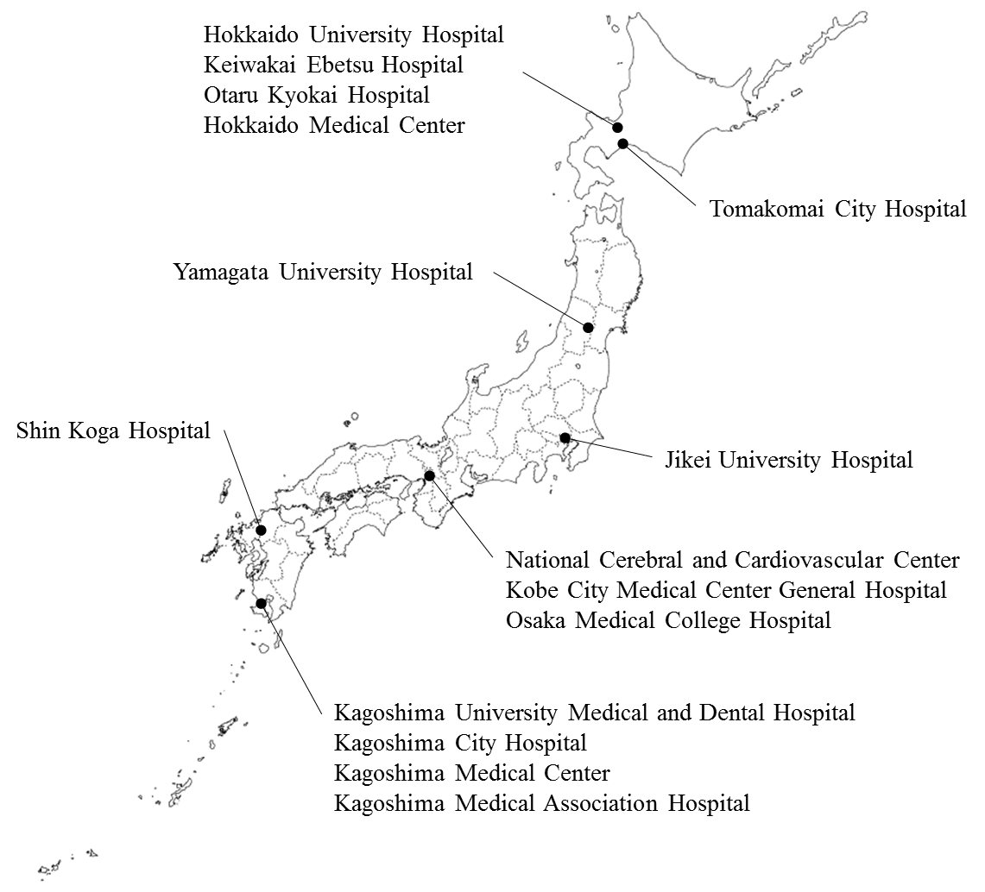

Participating Centers: Hokkaido University Hospital, Sapporo, Japan; Keiwakai Ebetsu Hospital, Ebetsu, Japan; Otaru Kyokai Hospital, Otaru, Japan; Hokkaido Medical Center, Sapporo, Japan; Tomakomai City Hospital, Tomakomai, Japan; Yamagata University Hospital, Yamagata, Japan; Jikei University Hospital, Tokyo, Japan; Osaka Medical College Hospital, Takatsuki, Japan; National Cerebral and Cardiovascular Center, Suita, Japan; Kobe City Medical Center General Hospital, Kobe, Japan; Shin Koga Hospital, Kurume, Japan; Kagoshima University Medical and Dental Hospital, Kagoshima, Japan; Kagoshima City Hospital, Kagoshima, Japan; Kagoshima Medical Center, Kagoshima, Japan; Kagoshima Medical Association Hospital, Kagoshima, Japan.

Supplementary Appendix 1. Study Participants: Eligible and ineligible criteria
<Eligible criteria>
Participants were eligible for the study:
1) No contraindication to plain computed tomography and coronary computed tomography angiography
2) Aged between 50 and 74 years old of either sex
3) Signed informed consent form

<Ineligible criteria>
Participants were ineligible for the study if they had a history of:
1) Myocardial infarction
2) Procedures related to coronary artery disease (angioplasty or coronary artery bypass grafting);
3) Kawasaki disease;
4) Coronary artery anomaly;
5) Familial hyperlipidemia;
6) On active treatment for cancer with serious medical conditions which would prevent long-term participation;
7) Dialysis treatment;
8) Serious medical condition with psychological disorders
9) Contraindication for contrast computed tomography.

Supplementary Appendix 2. Statistical methods to evaluate previous published models and develop the updated clinical models using clinical risk factors only

We calculated the predicted probability based on published coefficients and C-statistic with 95% confidence intervals. Because patients with evidence of previous coronary artery disease (CAD) were excluded, we assumed all included patients had a normal resting electrocardiogram [1]. Since no information was available on chest pain characteristics other than typical angina, all symptomatic patients who did not have typical angina were assumed to have non-specific angina [2]. Calibration of the models was assessed with calibration plots graphically, calibration-in-the-large, and tested with the Hosmer-Lemeshow goodness-of-fit test [3].
We performed the external validation of existing probability models using clinical risk factors for obstructive CAD (supplementary table 4). In the NADESICO population, the C-statistics for previously published models [4, 5] of probability for CAD varied between 0.58 and 0.66. Since those published models showed poor calibration for CAD with a Hosmer-Lemeshow of p<0.001 indicating a poor fit, we updated the model using clinical risk factors (clinical model), which took into account sex difference. Variables from existing models were entered in a multivariable random-effect logistic regression model with a random intercept to allow for heterogeneity in CAD prevalence across hospitals when p<0.1 at the univariate analysis. We omitted variables with odds ratios less than 1.01 and non-significant. We used bootstrapping with 1,000 replications for internal validation to correct the model for overfitting [6]. In the updated clinical models, the c statistics were slightly improved, but still low with the value of 0.67 in women and 0.66 in men (supplementary table 5). Thus, the impact of the clinical model using clinical risk factors only on the C-statistics was limited, even when we updated the model in both women and men.

Supplementary Results

Supplementary Table 1. Patients characteristics in derivation and validation cohorts
Characteristic | Derivation cohort (n=661) |  | Validation cohort (n=330)
 | Women  (n=294) | Men  (n=367) | Women  (n=162) | Men  (n=168)
Mean (SD) age, years | 65.0 (6.4) | 64.4 (6.5) | 65.6 (6.7) | 64.3 (7.0)
Current smoker | 21 (7.1%) | 71 (19.4%) | 13 (8.0%) | 28 (16.7%)
Current or past smoker | 54 (18.4%) | 307 (83.7%) | 33 (20.4%) | 125 (74.4%)
A history of CAD | 9 (3.1%) | 42 (11.4%) | 10 (6.2%) | 14 (8.3%)
Hypertension | 119 (40.5%) | 144 (39.2%) | 66 (40.7%) | 71 (42.3%)
Diabetes mellitus | 77 (26.2%) | 123 (33.5%) | 37 (22.8%) | 48 (28.6%)
Dyslipidemia ‡ | 200 (68.0%) | 252 (68.7%) | 118 (72.8%) | 120 (71.4%)
Mean (SD) Body Mass Index, kg/m² | 23.6 (3.7) | 24.4 (3.3) | 23.6 (3.7) | 24.6 (2.8)
Overweight and obesity * | 94 (32.0%) | 135 (36.8%) | 47 (29.0%) | 69 (41.1)
Estrogen status † | 17 (5.8%) | ― | 6 (3.7%) | ―
Systolic blood pressure, mmHg | 135.1 (19.3) | 134.6 (18.0) | 133.6 (17.3) | 134.7 (16.3)
Total cholesterol | 211.9 (35.7) | 193.0 (32.4) | 210.5 (34.2) | 194.5 (33.6)
HDL-cholesterol | 61.0 (14.8) | 52.6 (12.5) | 60.4 (15.6) | 52.1 (12.7)
Coronary calcium score
Median (IQR) | 3 (0-70) | 63 (2-302) | 6 (0-80) | 46 (1-307)
Mean (SD) log transformed ‡ | 2.1 (2.3) | 3.7 (2.6) | 2.2 (2.3) | 3.5 (2.5)
0 | 131 (44.6%) | 82 (22.3%) | 73 (45.1%) | 38 (22.6%)
>0 to <100 | 103 (35.0%) | 117 (31.9%) | 50 (30.9%) | 63 (37.5%)
100 to <400 | 41 (14.0%) | 89 (24.3%) | 30 (18.5%) | 33 (19.6%)
≥400 | 19 (6.5%) | 79 (21.5%) | 9 (5.6%) | 34 (20.2%)
Obstructive CAD | 62 (21.1%) | 136 (37.1%) | 37 (22.8%) | 62 (36.9%)
Obstructive CAD in patients with
CAC = 0 | 10 (7.6%) | 3 (3.7%) | 3 (4.1%) | 3 (7.9%)
CAC >0 to <100 | 23 (22.3%) | 28 (23.9%) | 11 (22.0%) | 17 (27.0%)
CAC 100 to <400 | 17 (41.5%) | 45 (50.6%) | 16 (53.3%) | 11 (33.3%)
CAC ≥400 | 12 (63.2%) | 60 (76.0%) | 7 (77.8%) | 31 (91.2%)
SD, standard deviation; IQR, inter quartile range; CAD, coronary artery disease; HDL, high-density lipopritein.
* Defined as body mass index 25 kg/m² or over.
† Estrogen status was considered positive if women were premenopausal or had oral estrogen replacement therapy and negative if they were postmenopausal and were not on estrogen replacement therapy.
‡ Natural logarithm of coronary calcium score +1.

Supplementary Table 2. Model discrimination (C-statistics) in validation cohort
 | Validation cohort
 | Women | Men
Clinical model | 0.73 (0.64-0.82) | 0.66 (0.58-0.75)
+ CAC continuous* | 0.88 (0.81-0.94) | 0.83 (0.76-0.89)
+ CAC categorical† | 0.86 (0.79-0.92) | 0.85 (0.78-0.91)
CAD = coronary artery disease; CAC = coronary artery calcification; CI = confidence interval; NRI = net reclassification index.
* Clinical model includes age, systolic blood pressure, use of blood pressure-lowering medication, total cholesterol, high-density lipoprotein cholesterol, and current smoker.
† CAC continuous = ln (CAC score + 1)

Supplementary Table 3. Net reclassification improvement for the estimation of coronary artery disease using conventional clinical risk variables combined with coronary artery calcification score in women and men of the derivation cohort
Women (n=294)
Probability of obstructive CAD based on clinical model | Probability of obstructive CAD based on CAC model (Clinical + CAC) *
 | Low  (< 30%) | Intermediate  (30 – 60%) | High  (≥ 60%) | Total
Low (< 30%)  Patients with CAD, n  Patients without CAD, n  Total patients, n  Observed risk, % | 22  174  196  11.2 | 15  23  38  39.5 | 3  2  5  60.0 | 40  199  239  ―
Intermediate (30 – 60%)  Patients with CAD, n  Patients without CAD, n  Total patients, n  Observed risk, % | 3  17  20  15.0 | 9  12  21  42.9 | 10  4  14  71.4 | 22  33  55  ―
Total patients, n  With CAD, n  Without CAD, n  Total | 25  191  216 | 24  35  59 | 13  6  19 | 62  232  294
Reclassification: 24.8% †
Category NRI: 0.33 †
Men (n=367)
Probability of obstructive CAD based on clinical model | Probability of obstructive CAD based on CAC model (Clinical + CAC)
 | Low  (< 30%) | Intermediate  (30 – 60%) | High  (≥ 60%) | Total
Low (< 30%)  Patients with CAD, n  Patients without CAD, n  Total patients, n  Observed risk, % | 5  52  57  8.8 | 10  15  25  40.0 | 4  3  7  57.1 | 19  70  89  ―
Intermediate (30 – 60%)  Patients with CAD, n  Patients without CAD, n  Total patients, n  Observed risk, % | 14  90  104  13.5 | 39  55  94  41.5 | 64  16  80  80.0 | 117  161  278  ―
Total patients, n  With CAD, n  Without CAD, n  Total | 19  142  161 | 49  70  119 | 68  19  87 | 136  231  367
Reclassification: 58.6% †
Category NRI: 0.71 †
CAD = coronary artery disease; CAC = coronary artery calcification; CI = confidence interval; NRI = net reclassification index.
* This CAC model is the CAC model 1 (= Clinical model + ln[CAC score + 1]) in Table 2B.
† We adopt the incrisk command of STATA to calculate these parameters.

Supplementary Table 4. Pre-test probability of published models to identify obstructive coronary artery disease in derivation (original) studies and in NADESICO participants
 | Linear predictor | Discrimination,  C-statistics (95% CI) |  | Calibration
 |  | Derivation study | Validation in NADESICO participants | Calibration-in-the-large (p-value) | H-L test, χ²  (p-value)
Diamond & Forrester, 1979 | -7.52, +0.09 for age, +1.35 for male sex, +3.77 for typical chest pain, +1.70 for atypical chest pain | 0.78  (0.76 – 0.79) | 0.62  (0.58 – 0.66) | -1.54 (<0.001) | 63.0  (<0.001)
Duke Clinical Score, 1993 | -7.376, +0.1126 for age, -0.328 for female gender, -0.0301 for age*gender interaction, +2.581 for typical angina, +0.976 for atypical angina, +2.596 for smoking, +1.845 for hyperlipidemia, 0.694 for diabetes, -0.0404 for age*smoking interaction, -0.0251 for age*hyperlipidemia (interaction), 0.550 for sex*smoking (interaction) | 0.87  (0.82 – 0.92) | 0.66  (0.62 – 0.70) | -1.74 (<0.001) | 131.1  (<0.001)
Morise, 1997 | -4.522, +0.0824 for age, -0.454 for male gender, +0.647 for symptoms, +0.537 for estrogen status, 0.367 for diabetes, 0.183 for hypertension, +0.24 for smoking, +0.203 for hyperlipidemia, +0.284 for obesity, -0.074 for body mass index | ― | 0.58  (0.54 – 0.62) | -1.56 (<0.001) | 52.4  (<0.001)
NADESICO, Nationwide Gender-specific Atherosclerosis Determinants Estimation and Ischemic Cardiovascular Disease Prospective Cohort Study
We performed the external validation of existing probability models for obstructive CAD (Online Table 1). In the NADESICO population, the C-statistics for previously published models [4, 5] of probability for CAD varied between 0.58 and 0.66. All published models showed poor calibration for CAD, with a Hosmer-Lemeshow of p<0.001, indicating a poor fit.

Supplementary Table 5. Logistic regression analysis (sensitivity analysis)
 | Women (n=456) |  |  | Men (n=535)
 | Odds ratio  (95% CI) | P-value | C-statistics | Odds ratio  (95% CI) | P-value | C-statistics
A. Clinical model 2*
Age  Current  smoker  Dyslipidemia  Diabetes | 1.07  (1.00 – 1.14)  ―  1.45  (0.70 – 3.01)  2.32  (1.10 – 4.90) | 0.062  ―  0.319  0.027 | 0.67  (0.61 – 0.73) | 1.03  (1.00 – 1.08)  1.38  (0.79 – 2.40)  1.69  (0.89 – 3.19)  2.63  (1.60 – 4.30) | 0.052  0.253  0.108  <0.001 | 0.66  (0.61 – 0.71)
B. CAC model 3 (= Clinical model 2 + lnCAC †)
Age  Current smoker  Dyslipidemia  Diabetes  CAC score | 1.01  (0.92 – 1.10)  ―  1.09  (0.63 – 1.90)  1.75  (0.76 – 4.00)  1.64  (1.37 – 1.96) | 0.875  ―  0.759  0.188  <0.001 | 0.81  (0.76 – 0.86) | 0.98  (0.93 – 1.03)  1.15  (0.48 – 2.80)  1.27  (0.54 – 3.00)  2.02  (1.04 – 3.92)  1.74  (1.56 – 1.95) | 0.429  0.751  0.585  0.038  <0.001 | 0.83  (0.80 – 0.87)
C. CAC model 4 (= Clinical model 2 + categorical CAC)
Age  Current  smoker Dyslipidemia  Diabetes  Categorical CAC score  0  >0 to <100  100 to <400  ≥400 | 1.02  (0.94 – 1.10)  ―  1.15  (0.65 – 2.02)  1.77  (0.79 – 3.95)  reference  3.54  (1.88 – 6.66)  10.8  (6.85 – 17.2)  24.7  (8.10 – 75.6) | 0.694  ―  0.629  0.164  Reference  <0.001  <0.001  <0.001 | 0.79  (0.74 – 0.84) | 0.99  (0.93 – 1.04)  1.10  (0.48 – 2.51)  1.35  (0.57 – 3.22)  2.01  (1.12 – 3.62)  reference  6.26  (2.73 – 14.4)  14.8  (6.13 – 35.6)  74.6  (23.5 – 237.0) | 0.626  0.816  0.497  0.020  reference  <0.001  <0.001  <0.001 | 0.83  (0.79 – 0.86)
The clinical model in women included age, dyslipidemia, and diabetes, while that in men included age, smoking status, dyslipidemia, and diabetes. Both clinical models had a significant effect for diabetes (odds ratio, 2.32 [95% confidence interval, 1.10-4.90] vs. 2.63 [1.60-4.30]).

Supplementary Table 6. Net reclassification improvement for the estimation of coronary artery disease using conventional clinical risk variables combined with coronary artery calcification score in women and men (sensitivity analysis)
Women (n=456)
Probability of obstructive CAD based on clinical model | Probability of obstructive CAD based on CAC model 3 (Clinical model 2 + CAC)*
 | Low  (< 30%) | Intermediate  (30 – 60%) | High  (≥ 60%) | Total
Low (< 30%)  Patients with CAD, n  Patients without CAD, n  Total patients, n  Observed risk, % | 22  228  250  8.8 | 27  48  75  36.0 | 4  5  9  44.4 | 53  281  334  ―
Intermediate (30 – 60%)  Patients with CAD, n  Patients without CAD, n  Total patients, n  Observed risk, % | 4  44  48  8.3 | 24  24  48  50.0 | 18  8  26  69.2 | 46  76  122  ―
Total patients, n  With CAD, n  Without CAD, n  Total | 26  272  298 | 51  72  123 | 22  13  35 | 99  357  456
Reclassification: 28.1% †
Category NRI: 0.43 †
Men (n=535)
Probability of obstructive CAD based on clinical model | Probability of obstructive CAD based on CAC model 3 (Clinical model 2 + CAC)
 | Low  (< 30%) | Intermediate  (30 – 60%) | High  (≥ 60%) | Total
Low (< 30%)  Patients with CAD, n  Patients without CAD, n  Total patients, n  Observed risk, % | 12  82  94  12.8 | 12  27  39  30.8 | 10  2  12  83.3 | 34  111  145  ―
Intermediate (30 – 60%)  Patients with CAD, n  Patients without CAD, n  Total patients, n  Observed risk, % | 16  103  119  13.4 | 31  71  102  30.4 | 58  18  76  76.3 | 105  192  297  ―
High (≥ 60%)  Patients with CAD, n  Patients without CAD, n  Total patients, n  Observed risk, % | 2  10  12  16.7 | 4  12  16  25.0 | 53  12  65  81.5 | 59  34  93  ―
Total patients, n  With CAD, n  Without CAD, n  Total | 30  195  225 | 47  110  157 | 121  32  153 | 198  337  535
Reclassification: 52.0% †
Category NRI: 0.56 †
CAD = coronary artery disease; CAC = coronary artery calcification; CI = confidence interval; NRI = net reclassification index.
* This CAC model is the CAC model 1 (= Clinical model + ln[CAC score + 1]) in Table 2B.
† We adopt the incrisk command of STATA to calculate these parameters.

Supplementary Figure 2. Probability of obstructive CAD predicted by CAC model 3 against the risk predicted by clinical model 2 (sensitivity analysis)
Gray area = Both models did not change the risk categories; blue area = reclassified higher categories by CAC model; pink area = reclassified lower categories by CAC model; hollow circle = CAD; solid circle = non-obstructive CAD. The graph shows the probability for CAD in women and men predicted by the clinical model (horizontal axis) against the risk predicted by CAC model (vertical axis). Lines at predicted probabilities of 30% and 60% are superimposed to show reclassification over clinically relevant cut points.
NADESICO, Nationwide Gender-specific Atherosclerosis Determinants Estimation and Ischemic Cardiovascular Disease Prospective Cohort Study; CAD, coronary artery disease; CCTA, coronary computed tomography angiography.

Supplementary Figure 3. Risk stratification capacity of clinical model 2 and CAC model 3 (sensitivity analysis)
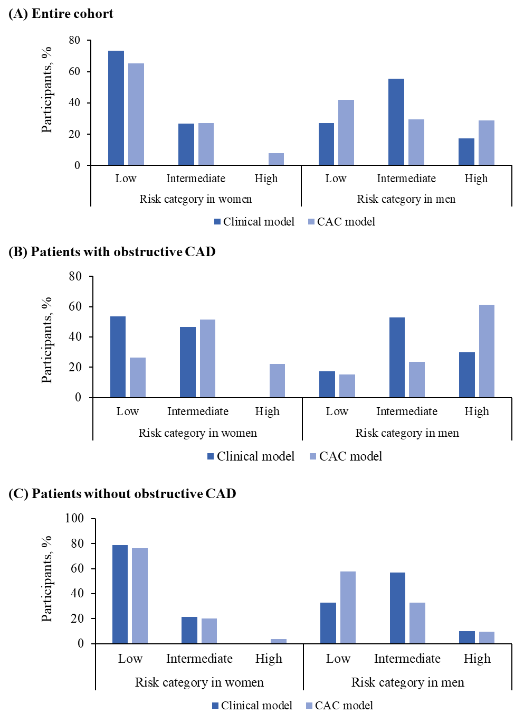

- Entire cohort, (B) patients with obstructive CAD, and (C) patients without obstructive CAD.
Risk stratification capacity is each model’s capacity to allocate participants from intermediate to the highest and lowest risk categories: risk stratification capacity = (the prevalence predicted by clinical model) – (that by CAC model). CAD, coronary artery disease; CCTA, coronary computed tomography angiography.

References
1 Genders TS, Steyerberg EW, Hunink MG, et al. Prediction model to estimate presence of coronary artery disease: retrospective pooled analysis of existing cohorts. Bmj 2012;344:e3485.
2 Arbab-Zadeh A, Miller JM, Rochitte CE, et al. Diagnostic accuracy of computed tomography coronary angiography according to pre-test probability of coronary artery disease and severity of coronary arterial calcification. The CORE-64 (Coronary Artery Evaluation Using 64-Row Multidetector Computed Tomography Angiography) International Multicenter Study. J Am Coll Cardiol 2012;59:379-87.
3 Lemeshow S, Hosmer DW, Jr. A review of goodness of fit statistics for use in the development of logistic regression models. American journal of epidemiology 1982;115:92-106.
4 Morise AP, Haddad WJ, Beckner D. Development and Validation of a Clinical Score to Estimate the Probability of Coronary Artery Disease in Men and Women Presenting with Suspected Coronary Disease. The American Journal of Medicine 1997;102:350-6.
5 Pryor DB, Shaw L, McCants CB, et al. Value of the history and physical in identifying patients at increased risk for coronary artery disease. Annals of internal medicine 1993;118:81-90.
6 Steyerberg EW, Harrell FE, Jr., Borsboom GJ, et al. Internal validation of predictive models: efficiency of some procedures for logistic regression analysis. Journal of clinical epidemiology 2001;54:774-81.
7 Lay J-NHS-R. Nonparametric multivariate density estimation: A comparative study. IEEE Trans 1994;42:2795-810.

